**WASHLY: A CAR WASHING MOBILE APPLICATION**

A Capstone Project Presented to the Faculty of the College of Information Technology and Computer Science

University of the Cordilleras

In Partial Fulfillment

of the Requirements for the Degree

BACHELOR OF SCIENCE IN INFORMATION TECHNOLOGY

By

EDMOND AUJAY TARYOUWAY

IDRIS MAHMUD IDRIS MOHAMED

MOHAMMED FUAD AL-MAHWITI

APRIL 2022

**APPROVAL SHEET**

This project study entitled, WASHLY: A CAR WASHING MOBILE APPLICATION prepared and submitted by EDMOND AUJAY TARYOUWAY, IDRIS MAHMUD IDRIS MOHAMED, MOHAMMED FUAD AL-MAHWITI in partial fulfillment of the requirements for the degree BACHELOR OF SCIENCE IN INFORMATION TECHNOLOGY, has been examined and is recommended for acceptance and approval for oral examination.

PHILIP IRVING JACINTO, MIT

Adviser

Project Study Committee

LOVELY JEN REFORMADO, BSCS ROMA JOY FRONDA, MSMath

Member Member

LOVELY JEN REFORMADO, BSCS

Chairperson

**___________________________________________________________**

PANEL OF EXAMINERS

APPROVED by the Committee on Oral Examination on __________________ with a grade of _____________.

LOVELY JEN REFORMADO, BSCS

Chairperson

LOVELY JEN REFORMADO, BSCS ROMA JOY FRONDA, MSMath

Member Member

ACCEPTED AND APPROVED in partial fulfillment of the requirements for the degree BACHELOR OF SCIENCE IN INFORMATION TECHNOLOGY.

MELINDA A. BENINSIG, MIT JEFFREY S. INGOSAN,

MCSIT/CS PROGRAM CHAIR, Dean, College of

College of Information Information Technology

Technology and Computer and Computer Science

**ABSTRACT**

1. Title: Washly: A CAR WASHING MOBILE APPLICATION

1.1 Total No. of Pages: 130

1.2 Text No. of Pages: 15218

1. Author: Edmond Aujay Taryouway, Idris Mahmud Idris Mohamed, Mohammed Fuad Al-Mahwiti
2. Type of Document: Dissertation
3. Type of Publication: Unpublished
4. Accrediting Institution: University of the Cordilleras Gov. Pack Road, Baguio City CHED-CAR
5. Keywords: Car Wash, Baguio
6. Abstracts:

7.1 **Rationale / Background of the Study**

Baguio, on the Philippines’ Luzon island, is a mountain town of universities and resorts. Called the “City of Pines,” it’s particularly popular in summer due to unusually cooler weather. However, when tourists come to Baguio, we often discuss how many of them come using their private vehicles, but not know how they will wash or clean their car. Too often, They will go out looking for a car washing place because they are not familiar with the city, even for those who have been living in Baguio. So, this is seen as a problem for not only tourists but also for the residents of Baguio.

7.2 **Summary**

The researchers were able to design and develop Washly: A car Washing Mobile Application, specifically, it aims to address the following:

1. To identify the information requirements of the proposed system.

2. To identify architectural framework of the proposed system

3. To identify the features of the proposed system.

and

4. To measure the extent of usability of the proposed system.

7.3 **Findings of the Study**

Based on the gathered data from the document analysis, interview, and usability testing, the following answered the objectives of the study:

1. The researchers were able to identify the Information Requirement needed for the proposed system the user information, (Full name, email, number, password) Hardware Requirements used for app development and User Phone,(RAM 4GB to 8GB, Disk Space 2GB to 4GB, Screen Resolution 1280 x 800, Wi-fi, File/Gallery, CPU Quad-Core to Octa-Core) Software Requirements for user phone,(Operating System Android 6.0 to Android 9.0, Database Firebase).
2. The researchers were able to identify the architectural framework of the proposed system. The Use Case diagram specifies the events in a system and how those events flow. The process view which is the activities diagram shows step by step in how the process is done. The development view representing the package diagram shows how the package is moved from one package to another. The Sequence diagram is the logical view it visualizes as well as validates various runtime scenarios. The deployment diagram represents the physical view of an application and for constructing executable code of the software application. The Application topology mapping is designed to map or diagram the layout of the applications,and how they are currently performing in terms of efficiency and availability.
3. The researchers were able to identify the features of the proposed system, Online services as its main feature.
4. The researchers were able to measure the extent of usability through conducting a survey to different users of car owners in Baguio Residents and Tourists. It obtained high and positive feedback therefore concluded that the system is considered usable by the target users and obtained a SUS score of 69% in terms of usability which was measured through the System Usability Scale, which is interpreted as ‘GOOD’. This means that the system is considered usable by the target Users.

8.4 **Conclusions**

Based on findings, the conclusions below are hereby presented.

1. Functionality and Content of the application Washly using the information requirements such as the the user information, (Full name, email, number, password) Hardware Requirements used for app development and User Phone,(RAM 4GB to 8GB, Disk Space 2GB to 4GB, Screen Resolution 1280 x 800, Wi-fi, File/Gallery, CPU Quad-Core to Octa-Core) Software Requirements for user phone,(Operating System Android 6.0 to Android 9.0, Database Firebase).

2. The Architectural Frameworks are represented through following diagrams; Use case Diagram, Activities Diagram, Package diagram and the Sequence Diagram is the logical design while the Deployment diagram shows the physical design and Application Topology Mapping. Application topology mapping is designed to map or diagram the layout of the applications,and how they are currently performing in terms of efficiency and availability. Deployment diagrams show the configuration of runtime processing elements and the software components, processes, and objects that execute on them.

3. The main features of the proposed system are book now , view your bookings and chat features for the user and for the admin it includes view all users, view new booking, show all booking and chat features.

4. Based on the result of the System Usability Scale, the researchers have received a score of 69**%** and according to the chart; this means that the proposed system has perceived acceptability of acceptable, a score letter of B on the measure of usability of the proposed system.

8.5 **Recommendations**

Based on the conclusions, the recommendations below are hereby presented.

1. For future researchers to explore other software platforms that will fit the features of the system;
2. The researchers recommend future developers add a feature that lets users suggest locations to the admin;
3. For future researchers to develop a more improved
4. system that is more efficient and easier to navigate even by the age group not used to online platforms;
5. The researchers recommend future developers add an auto generated Chat from the admin feature wherein the app;

**ACKNOWLEDGMENT**

The researcher would like to express their deep and sincere gratitude to those who took part in the success of this Capstone Project.

First and foremost, the researcher would like to thank God Almighty for giving the strength, knowledge, ability and opportunity to undertake this project and to persevere and complete it satisfactorily. Without His blessings, this achievement would not have been possible.

Ma'am. Melinda A. Beninsig, Capstone 1 and Capstone 2 teacher-in-charge for her guidance in making the project documentation and for her unending patience, motivation, and support.

To Sir. Philip Jacinto, being the researcher’s project adviser for his patience, suggestions, time, consideration, and valuable information he has devoted and shared with the researchers to complete and improve this Capstone Project.

To Ma’am Roma Joy Fronda and Ma’am Lovely Jen Reformado for being the researcher’s project Panel list for their guidance in making the project documentation and for unending patience, motivation, and support to complete and improve this Capstone Project.

To the College of Information Technology and Computer Science students, for their help and encouragement.The researchers would like to thank their friends for the emotional support, suggestions, and help. The researchers would also like to thank their respective families for giving encouragement and comfort, emotional and financial support, and for the motivation to finish this project. This project would never be completed without their help.

E.A.T

I.M.M

M.F.A

**DEDICATION**

The researchers dedicate this project to their loved ones, especially to their respective family and friends for their unending support and words of wisdom. To their adviser, panel members, and teacher-in-charge for guiding and giving valuable information and suggestions throughout the accomplishment of this project. And above all, to God Almighty, the source of wisdom, knowledge and understanding. He has been the source of strength throughout the accomplishment of this project.

**Taryouway Edmond**

**Mohamed Idris**

**Al-Mahwiti Mohammed**

**TABLE OF CONTENTS**

Page

TITLE PAGE .............................................. 1

APPROVAL SHEET .......................................... 2

ABSTRACT ................................................ 3

ACKNOWLEDGEMENT ........................................ 10

DEDICATION ............................................. 12

TABLE OF CONTENTS ...................................... 13

LIST OF FIGURES......................................... 16

LIST OF TABLES.......................................... 18

CHAPTERS

1 INTRODUCTION

Background of the Study .................19

Importance of the Study .................51

Statement of the Problem .. .............52

Objectives of the Study ................. 53

Definition of Terms ..................... 53

2 METHODOLOGY

Software Development Methodology ........ 56

Scope and Delimitation of the Study ..... 62

Data Gathering Techniques ............... 63

Sources of Data ......................... 65

Software Development Tools .............. 66

3 FINDINGS OF THE STUDY

Information Requirements of the System .. 68

Architectural Framework of the System ... 69

Features of the Proposed System ......... 85

Measure of Usability ................... 101

4 CONCLUSIONS AND RECOMMENDATIONS

Conclusions ............................ 106

Recommendations ........................ 107

REFERENCES ....................................... 108

APPENDICES ....................................... 117

1. System Usability Scale ................. 117
2. Sample Result of Testing ............... 118
3. Important Codes ........................ 124

CURRICULUM VITAE ................................. 125

**LIST OF FIGURES**

Figure No. Figure Title Page

1 Feature Driven Development Methodology......... 25

2 Use Case Diagram .............................. 26

3 Sequence Diagram ...............................40

4 Activities Diagram ............................ 54

5 Package Diagram ............................... 63

6 Application Topology .......................... 66

7 Deployment Diagram ............................ 67

8 Opening Screen ................................ 68

9 User Login and Registration Page .............. 68

10 User Homepage ................................. 70

11 Book Now Page ................................. 71

12 Location Page ................................. 73

13 Your Booking Page ............................. 74

14 User Chatbox .................................. 74

15 Admin Login Page .............................. 75

16 Admin Home Page .............................. 76

17 Admin All Users Page ......................... 77

18 Admin New Booking Page ........................ 78

19 Admin All Booking Page ........................ 79

20 Admin Chat .................................... 80

**LIST OF TABLES**

No. Title Page

1 General Guidelines of SUS Scores .............. 19

2 Percentile Rank ............................... 19

3 SUS Questionnaire ............................. 86

Chapter 1

**INTRODUCTION**

**Background of the Study**

Baguio, on the Philippines’ Luzon Island, is a mountain town of universities and resorts. Called the “City of Pines,” it’s particularly popular in summer due to unusually cooler weather. At its center is Burnham Park, with gardens and a lake. Nearby, Baguio Cathedral, completed in 1936, has a rose-hued exterior (Bautista, 2018). Hailed as the Summer Capital of the Philippines, Baguio is the top destination to go to if you want to take a break from the tropical heat in the lowlands. With average temperatures ranging from 15-23°C, the city rarely experiences temperatures higher than 26°C even during the warmest parts of the year. Because of this climate, Baguio is also home to beautiful plants that wouldn’t usually survive elsewhere in the county. Also nicknamed the City of Pines, you’ll be in for a treat with all the beautiful flowers and lush vegetation as you enter the vicinity (Philippines. Travel, 2018). The name Baguio conjures, for both the international and domestic traveler, a highland retreat in the Grand Cordillera in Northern Luzon, with pine trees, crisp cold breezes and low verdant knolls and hillocks. Its rich culture and countless resources have lured numerous investments and business opportunities to the city (Baguio.gov, 2020). And when it comes to Baguio city there is a lot of working residents and the amount of tourists that come to the city is very large and some of them might be visiting the city for the first time and are not familiar with the city so when a traveling tourist comes with his car, of course, it is more likely that the car would be dirty by the time they arrive in the city and when they try to look for a car washing place they will not find one easily because it’s their first time in the city (Lawrence 2020). The carwash is known as one of the most important urban services that bring about the production of a huge volume of wastewater with high turbidity and high chemical oxygen demand. Seasonal and car wash location features affect the quality of car wash wastewater. Various methods with a special focus on chemical processes have been employed for car wash wastewater treatment and eliminating different pollutants from this wastewater of great concern for the environment. Since most people don't go to car washes on a daily basis, price isn't necessarily the most important factor for customers when it comes to picking a car wash. Instead, they want to know that the car wash technicians will do a thorough job (The business plan 2016). It is important to wash your car fairly often. The idea that rainwater will clean your car also misses another element that has an impact on car care: not all water is the same. Performing a car wash on or within 1 day of heavy rainfall is the best option. Washing after rainfall will also allow you to clean those nasty mineral deposits from your car. If you don’t, they will etch into the paint and the car will need stages of paint correction. As a general rule of thumb, you should perform a wash after the rain, especially if you live in a highly polluted area. Even if it is a senseless or waterless wash (Wilkins, 2020). In this era, the most affordable way to reach out to customers is by using web apps and mobile apps. There are millions of mobile applications being launched every day. A mobile app is an application that uses an android OS for accessing the Application. The application can be as simple as a message board (Janardanan, 2018). Yes, a mobile car wash can make your vehicle clean and shiny even if there’s a severe drought in the area. It can also offer comfort and convenience, health, and safety, added durability, and eco-friendly options (Detail Xperts, 2019). And considering that now we are in the middle of the covid pandemic we have to follow the safety protocols. The COVID-19 pandemic we are currently living through has been like no other pandemic we have encountered in our lives. You want to take precautionary measures when you clean and disinfect your car in a similar way to healthcare workers that wear Personal Protective Equipment (PPE) (Prymak, 2021).

As the coronavirus pandemic continues, there’s little doubt that what seemed to be a temporary inconvenience is now truly a “new normal.” Fortunately, the car wash industry is in a unique position to navigate this situation better than a lot of businesses. But even in the business of cleaning, the coronavirus has presented new challenges…and opportunities. You are tasked with keeping customers and employees safe while still generating income (Davy, 2020). And also, To comply with social distancing regulations many car washes closed their waiting rooms and limited services to exterior cleaning only to minimize contact between customers and staff (Research and Markets, 2020). And our aim will be to satisfy the customers. We will be dedicated to establishing and maintaining the finest car wash operation in the area, specifically known for the quality of service provided and the management's commitment to the betterment of the community (THE DIRT BUSTER, 1993). To busy people, comfort and convenience are probably the top benefits a mobile car wash service can bring. No more lining up in tunnel car washes. No more traffic, you can have it done anywhere you wish – be it at your driveway, your office, at the gym, even in the parking lot of your child’s school. This will give you more time to spend with the ones you love (Detail Xperts, 2019). It’s fair to say that people around here love their cars. With the recent economic boom that brought vehicle ownership within easy reach of [many more consumers](https://visor.ph/industry/ranking-ph-car-brands-based-on-2017-sales-growth/) who previously could never afford their own four wheels, owning a car is a really big deal and a subject of great pride. Days and weeks are often spent reading reviews and comparing prices on the path to picking the right car, but when it comes to maintaining that prized possession, Filipino drivers paradoxically seem to be much less demanding. Almost all car wash places around here seem to be set up the same way. A shed-like structure with a tin roof and space for two to five cars that are run by a bunch of young guys, with a radio blaring in the background and, if you’re lucky, a waiting area for customers, tastefully furnished with plastic chairs and an ashtray. There also never seems to be a real pressure washer insight. Instead, tired-looking pumps mounted on the back wall suck water out of blue plastic drums before pushing it along ordinary garden hoses that are then used to rinse the vehicles.

This mangy piece of fabric is usually dragged across the paint job with varying degrees of enthusiasm, with the holder often not shying away from leaning over the bodywork or standing on the tires to reach those hard-to-access areas. After another low-pressure rinse, it’s time for the drying-off process that is facilitated by means of another dirty old rag. At the end of it all, you are usually left with something that kind of resembles a clean car, but it’s not an ideal process. And while I would never want to knock the entrepreneurial spirit of car wash operators. According to the record of the Department of Transportation, the number of vehicles registered in Baguio City shown in Figure 1 was approximately 9,815 in the second quarter of 2015 and 11,672 in 2016, an increase of about 15.9%. Its composition by vehicle type. The total number of private cars registered in the second quarter of 2016 is 2,870 (45% of the total), taxis: 806 (12%), jeepneys or public utility jeepneys: 834 (13%), buses: 20 (0.31%) and motorcycles: 1919 (30%). Keeping your car washed is a low-cost way to protect the value and maintain appearance. Contaminants such as dirt, pollen, tree sap, air pollutants, and deceased bugs can all damage the great-looking finish and paint on your vehicle. If you are one of those who wash their cars once their color starts fading due to dirt, you might be doing something wrong. Some people wash it once a week while a few get their hands on it once a month according to their feasibility. Washing your car on a daily basis provides a lot of benefits that I am going to share in this article.

In some car washes, The Washly application is followed by an empty space or idle zone. Wheel cleaning equipment, such as sill brushes or high-pressure wheel blasters, may be placed in the idle zone. A sill brush also known as a wheel brush or tire brush consists of an 8-foot-long brush assembly that is pushed against the car's wheels and door sill area. Brushes typically use flagged bristles, as dirt is usually most heavily concentrated on the lower parts of the car. The material on a sill brush may have alternating lengths or use material that is intentionally mounted off-center to allow wheel surfaces of various depths to be cleaned. Sill brushes rely on the rotation of a customer's car's wheels in order to achieve complete wheel contact. Similar to the CTAs, wheel brushes often only activate when the customer buys a wheel cleaning upgrade. Some car washes use wheel-rim disc brushes in addition to or in place of sill brushes. These assemblies extend out towards the wheel and follow it at the same speed as the conveyor while rotating at high speeds to clean the wheels. At the end of a car wash's washly idle zone is often a high-pressure arch that directs water at a vehicle's surface, whereas touchless car wash is automated, with the vehicle passing through a tunnel where the vehicle is cleaned; however, touchless car washes do not use the foam or cloth applicators that soft-touch washes use, instead relying on high-pressure washers to both clean and rinse the vehicle off. Sensors utilized by these washes allow for a more precise clean along with the vehicle's exact shape. To compensate for not physically contacting the vehicle, touchless washes use higher pressures and more caustic detergents than ordinary car washes, Because the vehicle is not physically touched during a touchless wash, the vehicle is at a lower risk of being damaged. However, touchless washes have a harder time cleaning off tougher materials or reaching difficult-to-reach locations on vehicles, and their usage of stronger chemicals can potentially damage a vehicle's paint finish. The use of water supplies and energy are self-evident since car washes are users of such resources. The professional car wash industry has made great strides in reducing its environmental footprint, a trend that will continue to accelerate due to regulation and consumer demand. Many car washes already use water reclamation systems to significantly reduce water usage and a variety of energy usage reduction technologies. These systems may be mandatory where water restrictions are in place.

Car wash technology has seen a vast number of changes in just over a hundred years. Fully automated car washes seem commonplace these days, but just over a hundred years ago, this type of technology was not even dreamed of. Car washes continue to evolve to this day to meet the needs of different customers. Various car wash options are available, from self-serve to full-service washes, to meet the specific demands and price points of different customers. In addition, car wash technology still continues to progress. Today’s car washes are becoming more environmentally friendly with the introduction of milder soaps, technology that requires less water and energy to operate, and water recycling systems that allow up to 95% of used wash water to be reused on future washes. With the high demand for car washes, it is likely that the car wash of today will be unrecognizable in 50 years. As time marched on, operators introduced more one-stop shop features that allowed for auto detailing and additional treatments to happen at the same time and location that they offered basic car washing. Customers were able to truly customize their experience based on what they wanted and needed, something that still holds true today. More and more drivers have switched away from doing the work of washing their cars at home, realizing the cost and time savings of heading to the car wash instead. Automation is the norm, and today’s consumers have more choice than ever. Drivers can choose full-service packages, basic, and express packages, attended car washes, or self-serve options. At every price point, and at every level of care, there is a car wash service that meets these needs. Drivers can pay with everything from credit cards and cash and other web- or mobile-based options at some car washes. Car wash service providers are focusing on environmental factors such as ensuring water reclamation as part of their processes, meeting standards and regulations within their local areas. Cars are an investment for many people, and, as such, drivers want to take care of their cars. Car wash service providers are acknowledging this by making regular washing affordable, knowing that a good, regular deep clean goes a long way in preserving the life of a car.

Many people change the oil regularly and replace tires whenever needed, but when it comes to washing their cars, they become lazy. Taking a shower is something that most Filipinos love to do. A good number of us like to take a bath probably because of two things: we want to relieve the tension brought upon by the tropical weather, and we want to eliminate dirt from our bodies. We bet that most *Filipinos* can not bear oily skin. The concept behind practicing good body hygiene can also be applied in keeping your car clean. A regular car wash can do wonders for your car, which is why you should visit a car wash service station or clean your car by yourself at least once a week. Here are some advantages of washing your car. First of all, it preserves your paint. Many people think that washing and waxing a car is a luxury and not necessary. In reality, maintaining your car’s exterior is extremely important in preserving it. Most cars naturally depreciate, but you can extend the life of a car and in turn preserve its value longer if you keep it clean. Dirt, grime, and salt are natural enemies to your car’s paint. If exposed for too long, they will eat away at it, not only damaging the paint but the metal too. Second, it can prevent costly repairs. As I alluded to in the last point, car filth can wreak havoc on your car's paint and body. Some of this damage is irreversible and will require complete replacement. Those repairs cost a lot of money, in general, and hurt the overall value of the car. Third, Clean cars are safer. According to statistics, you are likely to get in a car accident approximately once every 18 years. You should do anything you can to reduce those odds, including keeping your car clean. People get in accidents every year because of dirty windows reduce visibility. Cars naturally have several blind spots, and the smallest amount of dirt can reduce visibility tenfold. Fourth, Cleaning the interior is healthy. Many people allow the interiors of their cars to get far too dirty. If they lived in the same conditions in their home, people might see why it is important to clean the interior. Cleaning the interior of a vehicle eliminates harmful bacteria that can accumulate on steering wheels, upholstery, and dashboards. Fifth, A clean vehicle makes you proud. This might be the most important reason to keep a clean car. It has been scientifically proven that having a clean car makes you happy. How a person keeps their car says a lot about them. Take pride in your vehicle and keep it clean. No matter what new car you get, automobiles are still a major financial investment. Therefore, it’s natural to want to take great care of your vehicle, and the easiest way to do that is through frequent car washes and cleanings. For some, this is a weekly routine, and for others, it’s almost an obsession. But as you’re washing your car every week, or maybe even multiple times each week, one does have to wonder if too many car washes can damage your car. Well, let us put your fears to rest. While washing your car improperly can damage it, washing it as often as you’d like won’t hurt your vehicle, even if you do it every week. Keep in mind, however, that if you wax your car you may need to reapply that wax after each wash depending on how well it holds up. Therefore, washing it every day or even every week could be seen as excessive, unnecessary, and more work than is needed. But if you’re most worried about protecting when washing your car is the paint and clearcoat. And if you’re washing your car improperly, you will do damage to it, and washing improperly more frequently will do even more damage, of course. So, if you like to do frequent car washes, here are some tips to keep in mind so that over washing your vehicle doesn’t do any major harm: Properly hand washing a vehicle is best, but if you do use automatic washes, only use touch-free. Whenever possible use only vehicle-safe soap and water for your washes. If some scrubbing is necessary, be gentle and only use microfiber sponges or cloths to avoid scratches. The truth is, you need to take care of your car so that your car takes care of you. Yes, there are oil changes and routine shop visits, but the occasional run of the car wash is one basic form of car care that’s often overlooked. You spend a lot of hours inside your car. If that environment is clean, you can feel more focused and organized. Most people are happier if they keep neat living areas in their houses; the same is true for that vehicle where you may meditate or contemplate your days to and from work. Here are some reasons you should regularly visit the car wash. Protect the Paint Job with a Car Wash. Your car comes into contact with a lot of debris: dirt, bugs, bird droppings, salt, and grime. If left untreated, these deposits could eventually eat away at the finish and paint, damaging the metal beneath. A run through the car wash will eliminate these deposits. The simple rule of thumb is, when you can see the dirt on your car, it’s time for a wash. Car Washes Improve Fuel Efficiency. As absurd as it sounds, regular car washes will help to improve your car’s overall fuel economy.

A layer of dirt on your car increases drags, causing it to use more fuel. A washed and clean car allows for air to move more easily across its surface. Personal Pride and Well-Being. Much like your home, you feel better when your car is clean and spotless, rather than coated in a layer of dirt with a helpful “wash me” hand-drawn on the rear windshield. While your home occasionally becomes a bit messy, you still regularly clean the bathrooms and wipe down kitchen counters, It’s the same idea with your car. It’s your largest accessory, and a regular car wash will keep it looking its best. Maintain the Resale Value. Besides making you feel good, regular car washes will help maintain the appearance and overall resale value. Sure, you love your car, but a day will come when you’re in the market for a new and improved one. A regular car wash is an inexpensive way to keep your car looking great increasing its resale value. Quick and Easy. There is no denying that a quick run through the car wash is extremely convenient. For the price of ten to fifteen dollars and around ten minutes of your time, you can fit a car wash into even the busiest of schedules. It is a simple form of preventative maintenance that’ll keep your car protected and in good physical condition. Talking about the undercarriage of the car, an undercarriage wash is not necessary every time your car is washed, but it is recommended that you have this done once every season. A high-pressure undercarriage wash will eliminate any buildup of mud, salt, moisture, and other corrosive materials, preventing rust damage. Opting for a wheel cleaning is a purely cosmetic add-on at the car wash. Brake dust—the black residue that accumulates on rims—would not damage your vehicle the way dirt and grime will. If you want to keep your wheels and rims looking spotless, a wheel cleaning will do the trick—though it is not a requirement. Spray-on wax is another cosmetic addition that is not going to help a whole lot and the wax will enhance the existing shine and help prevent water spots when drying. On the other hand, car detailing usually includes a hand-wax, which improves the shine and protects the paint. By waxing your car, you are keeping the paint job in good shape. The natural deposits of dirt and salt that you gather from driving will corrode the body of your vehicle over time. The benefits of cleanliness extend to the engine, where a regular wipe down can prevent damage from the buildup of debris. And when it comes to using a mobile application for car washing: First Comfort and convenience, for busy people like you, are probably the top benefits a mobile car wash service can bring. No more lining up in tunnel car washes. No more traffic you can have it done anywhere you wish, be it at your driveway, your office, at the gym, even in the parking lot of your child’s school. This will give you more time to spend with the ones you love. Secondly, be aware that your car’s interior is crawling with germs and bacteria that can put your health at risk, this can be prevented by steam cleaning your interior. Not only can steam reach the deepest and darkest recesses of your car it can kill germs and bacteria upon contact. Thirdly Safety, A mobile car wash that also offers specialty professional detailing services can help eliminate the possibility of accidents by keeping vital areas of your vehicle as clean and functional as possible. For example, cleaning the engine with steam can help prevent engine fires; while rejuvenated headlights allow you to see the road clearly at night, and also you are more visible to other drivers. Added durability, A service that you shouldn’t miss when a mobile car wash details your car is waxing. This can protect your car’s paint from the ravages of natural elements like UV rays, sand, stone chips, rain, and so on. Eco-friendly option, having a clean car is great. It is our social responsibility to keep the environment clean and save water. Thus, your best option is a mobile car wash that uses steam cleaning. for example, uses only a pint of water for cleaning an average-sized car and just five gallons for an entire truck. Couple this with our use of all-natural cleaning products to ensure that no chemical runoff will pollute storm drains and other sources of water. Not to mention that you won’t pay a hefty penalty for cleaning your car at home. And when compared to traditional car washes, mobile car detailing has always offered many advantages. But with the spread of COVID-19, the benefits of mobile car detailing are more apparent than ever before. Due to the pandemic, people’s behaviors have changed. People are generally spending extra time at home and being more diligent about their hygiene habits. As a result, mobile car detailing has proven to be the best way to keep your car clean, since you don’t need to leave the house or use communal tools to take care of it. In a pandemic or not, mobile car detailing is a safe and convenient way to keep your car looking great. These days, nearly everyone is spending more time at home than they used to. Instead of heading out to the shops every day, many people now rely on delivery services and online retailers to get what they need. Similarly, getting your car cleaned is another task that can be done from the comfort of home. When you use a mobile car detailing service, professionally trained detailers will meet you wherever you are and bring all the required tools and equipment. One of the biggest impacts of COVID-19 was the increased focus on cleanliness and sanitation. These days, there are hand sanitizer stations everywhere you go, including shopping centers, banks, and restaurants.

This concern about hygiene has caused some car owners to think twice about using self-service car washes. That’s because the tools at these car washes are handled by many people each day. No one wants to spend their day waiting around to go through a public car wash. Life is already busy enough with work, school, and social obligations, so don’t add another time-consuming task to your day by going to your nearest car wash. Instead, you can book an appointment with a mobile car detailing service. They’ll arrive at a time that’s convenient for you and can work on your car while you focus on other priorities. Coronavirus has prompted many people to stop carrying cash and pay only by card. However, most self-service car washes require you to pay with cash. On the other hand, mobile auto detailing services simplify the payment process by accepting contactless transactions. With people advised to observe physical distancing and good hygiene habits amidst the pandemic, health experts have constantly reminded that the simple practice of handwashing with soap and clean water is also one of the most effective ways to prevent the spread of germs and viruses. With the COVID-19 pandemic, we have been taking extra effort to wash our hands with soap and water. We knew this before the outbreak, But there are times we neglect doing the right thing. We are told right from childhood to always wash our hands after playing, before eating, after using the toilet, and as often as possible. Handwashing is not only for people working in laboratories or hospitals. And sanitization doesn't just apply to humans but also Cars. Visibility is a key to accident prevention. Dirty windows and rear-view mirrors. If you keep them clean, you can better evaluate what’s going on around you. Plus, clean headlights lead to maximum illumination, a must for driving at night or in inclement weather. Think of the dirt that’s probably built up inside your car. Even if you are a tidy person, there’s probably bacteria on the hard surfaces. That’s not to mention dust and residue on the seats and flooring. It can lead to poor air quality, aggravating people with allergies or breathing problems. Having a clean car can increase the longevity of your vehicle. A layer of dirt actually makes your engine work harder. That’s because it increases drag on the vehicle. Your fuel economy goes down, therefore, if you don’t regularly wash the exterior of your vehicle. Reduced fuel economy means that a dirty car is a money out of your pocket. Your car may or may not be a status symbol, but it is an accessory with which you are regularly associated. You want your car to reflect the same pride you feel with your personal appearance. After all, you probably spent quite a bit of time thinking about the make, model, and color of the vehicle before you bought it. Why not keep it looking its best. Vehicles are subjected to daily dirt and grime. As you travel around your car builds up immense amounts of debris, some of it not even visible to the human eye. Just about every inch of your car is vulnerable. We all know a clean car looks great but some of these unexpected benefits of regular car washing might surprise you. Prevents illness. You might be surprised to know that a dirty vehicle can actually affect your health. As you run errands or go to work you encounter surfaces that have germs, so you wash your hands several times a day. The germs that come into contact with your car are also a cause for concern. As you drive throughout the day, think of all the contaminated surfaces a vehicle can come into contact with. Roads are very dirty, even if they appear to be clear. Keeping your car clean goes a long way to help you avoid germs that can get on your door handles and other exterior surfaces.

By taking your car into a local Car Wash monthly you can utilize all their car care and cleaning services on a regular basis. The convenience of a professional car wash can easily be added to any to-do list. The money and time spent on the regular washing of any car are well worth the effort. Ideally, a weekly car wash is not going to happen for most of us. If a weekly car wash from experts is not possible, simple tricks such as using wax finishes after a car wash can help extend the time between external car washes by protecting the paint. Keeping a small duster in the trunk of your car can also help keep dust build at bay. Weekly vacuuming can also help keep dirt and dust inside a car to a minimum. Bigger cleaning jobs should be left up to car washing experts. Dirt has many negative effects on the paint. Not only does it make the car look old but writing in the dirt on the vehicle can cause scratches and other permanent damage. Also, dirt that mixes with rain can create an acidic compound that can weaken the metal and show noticeable damage on the surface. Keeping the outside of the vehicle clean can also help with the resale value if a car owner plans to sell the vehicle later, however just because the outside is clean doesn’t mean that the harm to the vehicle or its passengers is gone.

Dirt is a carrier of bacteria, meaning that there can be a silent danger right in the middle of a common necessity that people use every day. Car owners trust their vehicles with their families, and even the safest drivers cannot protect those they love from the diseases found in the dirt in their cars. Some soil-related diseases include wound infections, gastroenteritis, and specific respiratory syndromes, many of these health-related symptoms are acquired simply by ingesting dust, or dirt, containing the bacteria. When dirt settles in a vehicle, the likelihood of someone ingesting some harmful bacteria increases significantly. Also, dirt inside the vehicle can affect the way that a driver feels in the long run. Whenever the driver and passengers are inside a clean car, they feel better about themselves and the time they spend in the vehicle. Taking the extra step to get a vehicle detailed could be the thing that changes a bad mood into a great one. Over time what begins to happen if dirt and other substances aren’t removed is that they can begin to eat away at your clear coat. While it looks harmless, dirt clings to a vehicle’s clear coat (like static electricity) and needs soap to loosen this bond and carry it away from time to time. Once a vehicle’s clear coat has been worn down to the paint layer, substances can then eat through the paint layer as well, eventually reaching the sheet metal and causing rust spots. This process starts slowly but really happens to all vehicles at some point. The problem with not washing your vehicle is that this process speeds up dramatically, causing damage many times *years* before it normally would happen. It’s that time of year again. Winter is approaching in the city of Baguio which means preparing your car for some nasty weather elements. If you live in Baguio, you will know what it means. And, with all the acid rain, road grease, and other unsavory elements that will attack your car this winter in baguio, getting a wax job to protect your paint might be a good idea. So why do we invest so much time and money in protecting our car when winter approaches. There are a number of reasons, all of which are equally important. First off, preventative car care protects our automobiles, so they last longer, also preserving resale value. Secondly, taking care of our vehicles prevents having costly repairs and frightening breakdowns. An overwhelming majority of car owners seem to know what to do, and why, when it comes to car care. The overwhelming majority of car owners seldom wash their cars on a regular basis. The irony here is that keeping your car clean has many significant financial and environmental benefits as well, especially when performed by a professional car wash. Let’s start with the financial rewards. In today’s environment, on the best of days, our cars are subjected to sun, salt from the sea, road grease, dead bugs, bird poop and smog. On bad days, our cars are subjected to salt from snow trucks, acid rain, tree sap, road slush and mud. Any one of these elements can eat away at a car’s metal, chrome and paint. Corrosion will occur and rust will appear under the carriage, in wheel wells, even in parts under the hood. It may not be noticeable right away, but over time it will degrade your car, diminishing its resale value. When it comes time to sell or trade you will be quite disappointed at how little your car is worth and how much you’ve lost financially. By having your car washed monthly, not only do you protect your investment and save money, you also ensure your continued freedom to go anywhere and do anything, not to mention your personal safety and security while on the road. Did you know that nearly $24 billion a year is spent on battling car corrosion damage. This cost is absorbed by you, the consumer, in three ways; funding automakers' efforts to research corrosion-resistant paints and coatings; fixing damage to your own vehicle caused by road and sea salt; or corrosion-related depreciation of cars. There is another important reason to keep your car professionally washed, protecting the environment. In 1972, the government established the Clean Water Act, which mandated professional car washes to pipe dirty water to treatment facilities or into state-approved drainage facilities. Washing your car at home pollutes the environment with soap and road grime such as oils, tar, and dirt washed from your car ends up in storm sewers that flow into lakes, streams and rivers. In fact, many North American cities have even banned charity car-washing events, which result in soapy discharge and wasted water. Regardless of all the other reasons mentioned, the environmental issue should be considered enough. After all, these lakes, streams and rivers could be those in which your children swim, or where you fish, or perhaps even live. Keeping them clean ensures a healthier future for all of us. Another consideration is this: a professional car wash uses about 32 gallons per car. Studies have shown that a 45-minute car wash at home can use more than 300 gallons of water. Treat your car the way you want it to treat you. Add a professional car wash to your monthly chores. And bring the kids. They’re never too young to start learning the value of good auto maintenance, inside and out. Some experts think you should wash your car once a week to maintain and protect it from the elements, but we here at Auto Bright would amend that statement. It’s during these months mentioned above where you should get your car washed once a week or, as many of our customers do, come in right after one of those events like a heavy snowstorm or a heavy pollen coating. During the summer months you can probably feel comfortable going a bit longer between washes — maybe two weeks or maybe you only come see us after a pigeon has come to see your car. You should know, though, that salt is one of the biggest enemies to your car and that even if you don’t see it on the surface, it could be on your undercarriage, in your wheel wells and other important parts of your car. This is important to remove because salt residue reacts with the metal in your vehicle and causes rust. Our all-cloth automatic car wash is designed to remove the salt from your car for this reason, but whether you decide to use one of our self-serve car wash bays, or if you decide to get your hose out and wash your car in your driveway, remember to clean the underside of your car thoroughly to prolong its life, it is resale value and it is shine. If your car could talk, it would thank you. And also, the simplest means can also protect your car and by that i mean using floor mats. Floor mats can make a big difference in a vehicle notably in cold winter climates where people bring slush, dirt and salt into a car. Salt stains can be particularly difficult to remove and look terrible over time. Using floor mats that are removable and can be thrown out and changed periodically is a great way to protect the interior of a vehicle, avoid salt and other types of stains. And cleaning your tires is important if you want your car to look its best! Since tires are the only part of your vehicle that touches the road while you’re driving. Aside from dirty wheels not being aesthetically pleasing, cleaning your tires is also a great way to limit corrosion or similar damage. Letting dirt and grime hang out too long can cause your wheel finishes to peel and can even make the rims more porous which could create tire pressure leaks. Driving with a slow leak in your tire is potentially dangerous because it can cause a flat tire. Once the tire becomes flat, it can become a blowout hazard. A blowout can cause you to lose control of the vehicle, putting yourself and others at risk for a car accident. If you notice your tires are not holding air like they are supposed to, or you have to keep putting air in your tire constantly, your tire may have a slow leak. That's why cleaning every inch of your car is important, even the small details in a car can affect the performance. The similar applications that we came across are “Ghaseel” and “SparkleYourCar”. The expectation from our application is to Book in advance and your car will be washed in the time and place of the customers preference. The prices will depend on the size of the vehicle and there will be different payment methods that suit the customer choice. And there will be a communication channel between the customer and the employee that will wash the car. And for the review, suggestions and feedback, after the service is done a dialog box will appear at the customer screen for the user to give their feedback or review.

**Importance of the Study**

The purpose of the research study is to focus on the design of the proposed app, Washly: A car washing mobile application. Which shall provide benefits to the following entities:

To Baguio Tourists. This research study shall provide a car wash based on the location and the time chosen by the customer.

To Baguio Residents. This research study shall help the Residents of Baguio cities to save time and have their car washed at any time and any place of their choice.

To The Researchers. This research study shall provide

knowledge and expertise in the researcher’s field of study.

The study shall serve as a training ground for the

researchers that shall benefit them in the field of

Information and Technology.

To the Future Researchers. This study shall serve as a basis for reference for implementing, utilizing, and developing projects that are similar to the proposal. Also, this research may serve as a reference to future researchers.

**statement of the problem**

Baguio is one of the cities that has the highest tourist coming in every year. In the past five years tourists have been complaining about how to wash the car because they find it difficult to look for a nearby car wash place. sometime when they try for hours in finding a car wash and they find one place it take time to wash the car because there are so many cars to be clean before theirs, so they have to go back the next day which of course they do not have the time to go back there and they decided to take their car back unclean that make them unhappy and sometime them sick as well. These are things that we are looking at to solve the problem in the city of Baguio, we want to give people a flexible time and a suitable place of their choice. This is where and when the problem arises, Baguio city has so many people coming in with their cars and they do not have a lot of car wash areas in Baguio for the tourists to clean their cars that become a serious problem in the city of Baguio. The people who get affected are the one who is driving and the other who is in it, so at the end of the day everyone is going to get ill on the way back home because the car is not clean. For the future researcher it is going to help them to understand how our research was conducted.

**Objectives of the Study**

The main objective of this study is to design and develop Washly: A car Washing Mobile Application, specifically, it aims to address the following:

1. To identify the information requirements of the proposed system.

2. To identify the architecture framework of the proposed system.

3. To identify the features of the proposed system.

and

4. To measure the extent of usability of the proposed system.

**Definition of Terms**

For the understanding of the study, some terms are

operationally defined:

Physical and logical design. The physical design is a graphical representation of a system showing the system internal and external entities and the flows of data into and out of these entities while the logical design is a graphical representation of a system showing the system process and the flow of data into and out of the process.

Durability. Durability is the ability of a physical product to remain functional, without requiring excessive maintenance or repair, when faced with the challenges of normal operation over its design lifetime.

Extent of usability. Extent of usability is the degree to which the system can be used by specified consumers to achieve quantified aims with effectiveness, efficiency, and satisfaction in a quantified context of use.

Hygiene. Hygiene is the conditions or practices conducive to maintaining health and preventing diseases, especially through cleanliness.

Information Requirements. Information requirements are theinformation needed to support a business. Systems analysts turn information requirements into functional specifications of a system.

Microfiber. Microfiber is a synthetic fiber that consists of polyester and polyamide.

Precautionary. Precautionary is to take some actions that will help to preserve your safety.

Reintroduce. Reintroduce is the describing of a thing in a different form from before.

Rust. Rust refers to when the car is exposed to moisture for too long and as a result the car paint will be affected.

Tourist. Tourist is a person who is visiting a place for pleasure and interest, especially when they are on holiday.

Usability. Usability is a measure of how well the application can be used by a particular user in a specific environment to accomplish a given purpose effectively, efficiently, and satisfactorily.

Visibility. visibility is when the car window is dirty, and it enables the driver to see clearly.

Chapter 2

**METHODOLOGY**

This chapter consists of a discussion about the

methodology that was chosen by the researchers, scope and

delimitation, data gathering techniques, sources of data, and software development tools the researchers will use to develop the proposed car washing application.

**Software Development Methodology**

Feature Driven Design (FDD) Methodology is a client-centric and pragmatic software process that follows the principles of the agile methodology with 5 basic activities. It highlights the classifications in all steps as it involves high levels of arrangement in order to define what the scopes of the project should be. FDD also has the more customary development of a systems-engineering life cycle model to differentiate it from the other agile methods, it also provides precise and significant progress and status information for the developers because the progress on each character is defined. This demonstrates a clear understanding of the system that the researchers worked on and helped them develop an analysis to help design the system. FDD is handy because it shows that one can focus on domain modeling on an iterative and incremental project and shows that agile-like methodologies can scale. The idea of Feature Driven Design is to develop the high-level features, the scope, and the domain object model and then use that to plan, design, develop and test the specific requirements and tasks based on the overarching feature that they belong to.

The researchers chose the feature-driven development or FDD methodology to serve as a source and guide in developing the proposed system. The FDD methodology includes programming, testing the system, modeling, and the complete packaging of the system. FDD is also a recommended methodology when it comes to complex and bigger projects and is also most praiseworthy for the proposed project. The

phases of Feature Driven Development (FDD) are shown in the figure.

Figure 1

Feature Driven Development Methodology

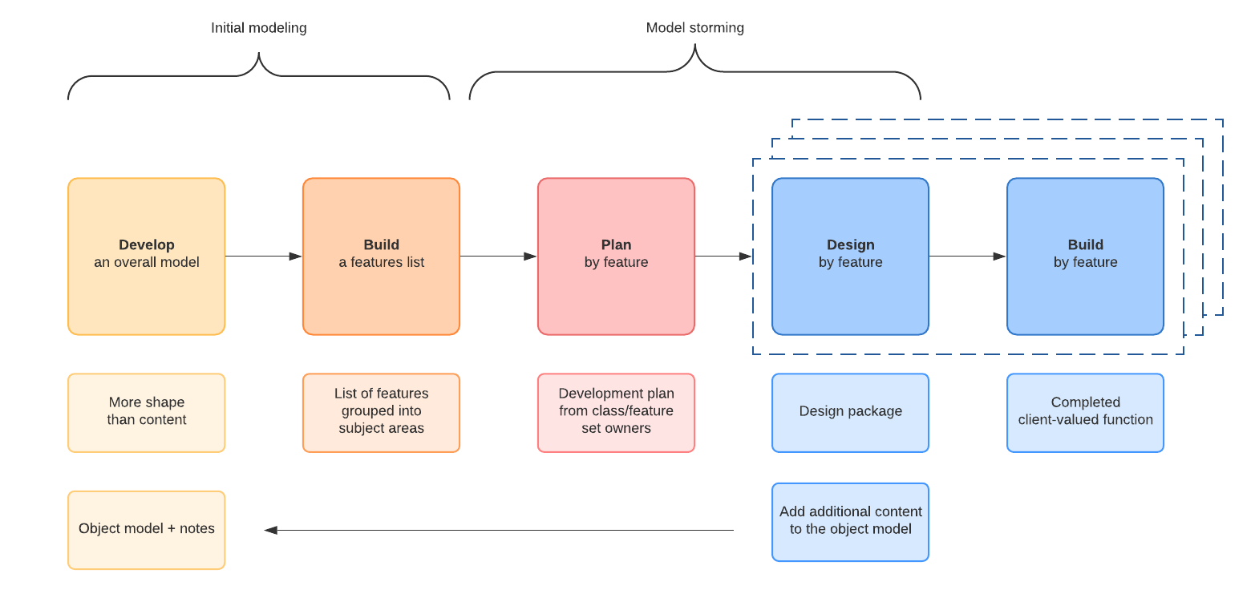

Phase 1: Develop an Overall Model. The modeling team comprises development members, domain experts, and the chief programmers. Development members are guided by an experienced Chief Architect. Initially high-level

walkthrough is done followed by a detailed walk-through

which gives an overview of the domain. Developing an overall model will give us an idea on how the architectural framework will be done.

In this phase, the researchers designed the

overall model of the system as well as an application and

demonstration of the scopes of the research and provided the researchers an overall understanding of how the system works. Each member have created their desired design

interface of the proposed project and all of the given

outputs would then be planned by all researchers and come

up with the final output for the proposed project. FDD is not ideal for smaller projects and does not work for projects where there is only one developer because it is hard for one or very few people to take on the various roles without help.

Phase 2: Build Feature List. Knowledge gathered during the initial modeling is used to identify a list of features by functionally decomposing the domain into subject areas. Subject areas each contain business activities, and the steps within each business activity form the basis for a categorized feature list.

In this phase, with the planned or decided interface

of the proposed system, the researchers decided what features would be the most suitable for the proposed system. It should not take longer than two weeks to develop any given feature. If a feature will take longer than two weeks to build, it should be broken up into smaller features.

Phase 3: Plan by Feature. The third activity in FDD is planning the sets of features for activities into a high-level plan. Developers are assigned to own particular

classes identified in the overall object model or

blueprint.

In this phase, researchers constructed a plan for

the application and the system. Researchers examined

the features needed for the application to fascinate the

users. After planning and finalizing all the desired

features listed, the researchers then decided to put

everything into a design that would complete the system and

determine the domain classes that are to be involved in

each design. After everything was decided by the

researchers, the researchers came up with solutions that determined the overall model according to the final output of the design interface. Places a high dependency on a chief programmer who needs to be able to act as a coordinator, lead designer, and mentor to new team members.

Phase 4: Design by Feature. A design package is produced for each feature. The programmer of the group selected a small group of features that are to be developed within two weeks. Together with the corresponding class owners, the programmer worked out detailed sequence diagrams for each feature and improve the overall system. Next, the class and method prologues are written, while a design inspection is held after.

After all, features was finalized and planned carefully, the researchers decided to put everything into one package and turn it into a design by making or building a prototype of how the design would look like and the desired structure of the system. After everything is put together, the final designs for the system were created. The problem that may be encountered here is if some members did not complete their tasks on time.

Phase 5: Build by Feature. The development class owners implement the items necessary for their class to support the design for the feature. Once the code is developed, carry on unit testing and code inspection. After a successful code inspection, the code can be built.

In this phase, after everything is finally well organized and finalized, the researchers created

a final blueprint and an initial prototype of the proposed System. It May not work well with older systems because there is already a system in place and no overall model to define it. You may need to start over and work from the ground up.

**Scope and delimitation of the study**

The researchers designed a washing app for cars in Baguio city. The researcher’s book in the advance app, the app allows the users to book their car washing appointment in advance. The researchers of this study focused on the development of the different features of the proposed system. The researchers were able to satisfy the different needs of their users that were gathered through data gathering techniques. The main focus of this project is a software that helps its users to book a car wash appointment wherever and whenever the user desires. The software uses GPS technology. The application will be run on android phones. The proposed system is limited to what features are available to android phones. The researchers observed and researched different car washing packages or services that the users might like. Which will give the users the option to choose between different packages with affordable prices. The application can be used in Baguio City, however it can be expanded upon by other researchers.

**Data Gathering Techniques**

The researchers used different data gathering

techniques and it is necessary to ensure that the data

gathered is accurate and defined, and that subsequent

decisions based on arguments embodied in the findings are

valid. Regardless of the field of study or preference for

defining data, accurate data collection is essential to

maintaining the integrity of research. This data is

crucial in the success of the study.

Interviews. This allowed the researchers to conduct a series of interviews and gather all the needed information and data about the experience of the people. It has been a structured interview and it allowed the researchers to know from the users what to change and what not to change about the application system.

Survey. This technique allowed the researchers to

collect the data needed for the study, analyze

the requirements needed, and use data collected from the

survey. An interview was assessed upon those who have used the car washing application in Baguio, as well as to users after testing the application system. And there has been a survey to measure the usability of our application. The researchers conducted a survey from random students and locals who took notice of the researchers which was a great help in the process of developing the features of the proposed system.

Questionnaires. were provided to the target population, such as tourists and residents of Baguio who own a car. Questionnaires were also provided to those people who choose to use the system, especially those people who wanted to attain security and to explore on their own agenda. This proposed system is applicable also to the government and authorities.

Document Analysis. This technique allowed the researchers to gather data about tourists attraction from the Department of Tourism and give voice and meaning around the proposed system. This data includes feedback after using our application. Analyzing documents incorporates coding content into themes similar to how focus groups or interview transcripts are analyzed.

**Sources of Data**

This study uses primary and secondary data. Primary

data being interviews, while surveys are the secondary data.

The interviews were done by gathering all the needed information and data in a series of interviews. The questions asked were relating to the experiences of those who have taken the car washing application in Baguio. The second round of interviews were in relation to the perception, experiences, and opinions of the people who have used the proposed system.

The surveys contained questions in which it seeks to find out what the user wanted in addition to the system's current features, as well as how the respondent reacted to the researcher's system. Responses gathered from the survey were used by the researchers to help further explain the usefulness of the system.

Document analysis is a method of data collection which involves analysis of content from written documents in order to make certain deductions based on the study parameters. The method is mainly used in qualitative research as a method of qualitative analysis.

**Software Development Tool**

Photoshop. It is an image editing software that allows users to manipulate, crop, resize, and correct color on digital photos. It is software that was used by the researchers to edit the user interface and to create an artistic design of the Offline Routes backgrounds.

Android studio. Android Studio is the official Integrated Development Environment (IDE) for developing applications for Android platform. It has a code editor that provides tools needed to build the mobile application that will be used by the researchers to make the program of the system.

Firebase. The researchers were using a cloud-hosted database by Google called Firebase Database. This tool is essential in storing and syncing data in real-time. Firebase Database, unlike other available database systems in the market, allows the instant sharing of real-time data among users.

Google maps. Google Maps is a web mapping platform and consumer application offered by Google. It offers satellite imagery, aerial photography, street maps, 360° interactive panoramic views of streets, real-time traffic conditions.

Chapter 3

**FINDINGS OF THE STUDY**

To further understand the proposed application Washly: A car washing mobile application, this chapter introduces the information requirements of the system, architectural framework of the system, an overview of the design feature of the proposed system and the measured the extent of usability of the proposed system.

**Information Requirements**

This section lists the information requirements of the system which are needed for information collected by the system. This information will be collected to display the full functionality of the system. This section also discusses the software and hardware requirements of the proposed mobile application.

System Requirements. The proposed mobile application is designed to run on Android smartphones with a minimum SDK version of 6.0 Lollipop (API Level 21) and has a target SDK version of Android 9.0 (API Level 31). An internet connection will be needed during signup as access to the system’s database will be required. Logging in will also need the internet to allow the system to access a user’s credentials in the firebase.

User Information. These are information that users will be placing in the system. Users are allowed to input data in the application through four different steps, the system provides its users the ability to input full name, number, email, and password, all these inputted data are save in the cloud firebase.

Location of the users. The location of the user here in Baguio shall be verified.

**Architecture Framework of Washly**

Architectural Framework refers to an encapsulation of a minimum set of practices and requirements for artifacts that describe a system's architecture. Frameworks serve as an overview on certain activities or flow of the system through a range of concepts, techniques, and diagrams that can either be clarified or integrated. Models are representations of how objects in a system fit structurally in and behave as part of the system. Views are a partial expression of the system from a particular perspective. A viewpoint is a set of representations of an architecture that covers a researcher's issues. It also pertains to an abstract representation of the data flows, inputs and outputs of the system. This is often conducted via modeling, using an over-abstract model of the actual system. In the context of systems, designs are included. These architectural frameworks are created to help researchers work on implementing and supporting processes in order to give researchers an idea of the features of the system. The logical view describes the object model of the design, the process view describes the concurrency and synchronization aspects of the design, the physical view describes the mapping of the software onto the hardware and shows the distributed aspects of the system. The researchers used UML diagrams to represent the use case view, sequence diagrams to represent the logical view, activity diagram to represent the process view, and deployment diagrams to represent the physical view for the Washly application.

Figure 2

Use Case Diagram of Washly

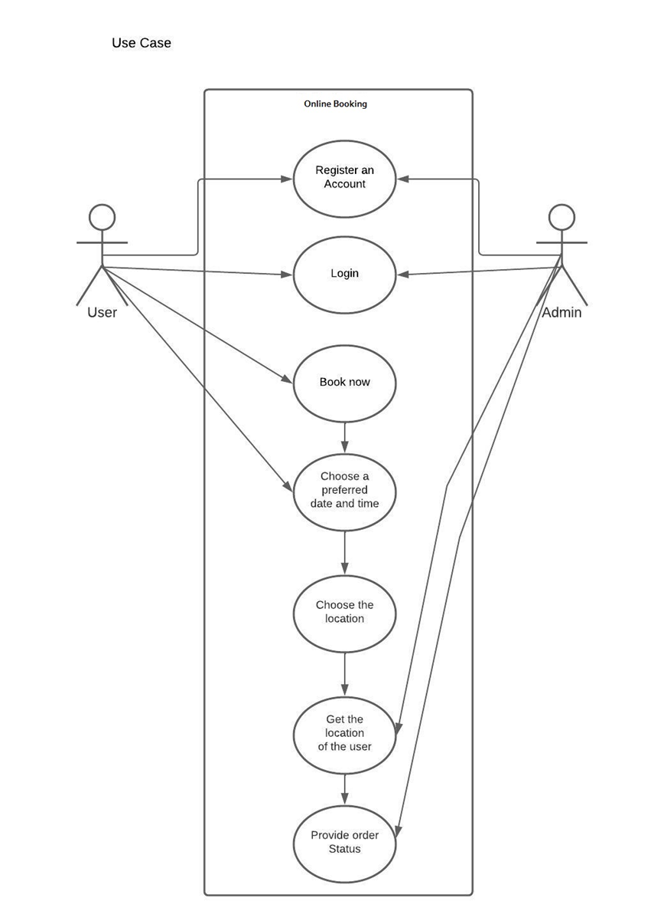

The use case diagram of the system. The diagram is a graphic depiction of the interactions among the user and Admin. The diagram specifies the events in a system and how those events flow, however, the use case diagram does describe how those events are implemented. It is a straightforward system as you can see in the diagram and the connections between and among the entertainers and the utilization cases. The utilization cases are the particular jobs played by the on-screen characters inside and around the framework. The graph has two entertainers to be specific: User and admin. The graph shows the data about the user and admin. The user will be the one utilizing the framework where the user will open the application. After the user opens the application, he or she will sign up or sign, then he or she is going to see the dash board with four different activities which are book now, your booking, chat and about us. In the book now section you are going to see all the packages in it where you can select the one of your choice, and every package has its own price and based on the size of a car. The first package is bronze, second is silver and the third is gold. In the bronze package you have a regular car and the price is fifty pesos, medium car the price is ninety pesos, and large car price is one hundred fifty pesos, they all have the same services which are body wash, interior vacuum dust, wiping cleaning and tires wash. For the second package the services offer are: body wash with shampoo, interior vacuum dust cleaning, light interior detailing with special products and tire wheels wash and shine. The regular car price is eighty pesos, medium car price is one hundred forty pesos and large car price is two hundred pesos. The gold package service is body wash with shampoo, interior vacuum, dust cleaning, light interior detailing with special products, tire wheels wash and shine and hard spots removal, the regular car price is one hundred twenty pesos, the medium car price is one hundred eighty pesos and large car price is two hundred fifty pesos. After you have seen the various packages and the services then you can select the package and the size of your car. After choosing that package you can move on to the date and time you want your car to be wash, after that the user will give the location, and lastly the admin will get the location of the place and provide order status.

Figure 3

Sequence Diagram of Washly

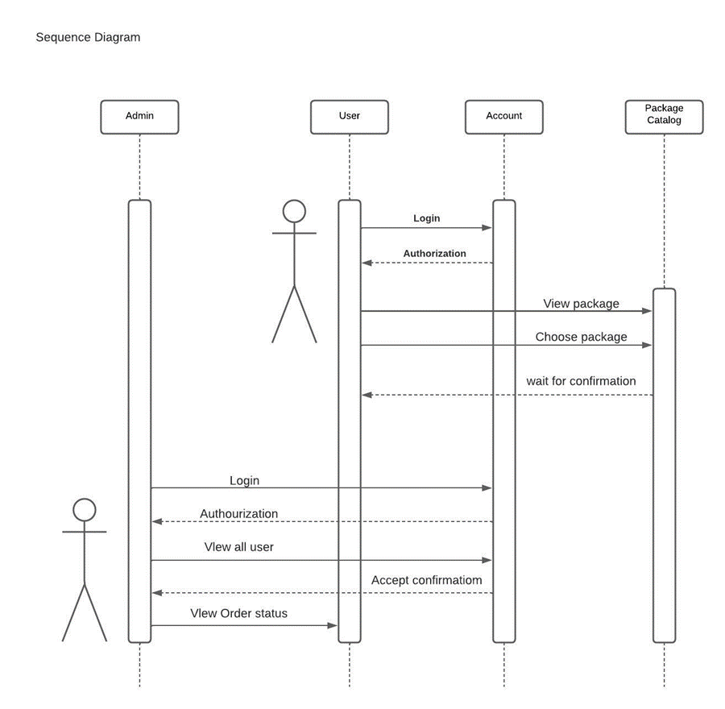sequence diagram of Washly details on how the operations are carried out. The diagram is a good way to visualize and validate various runtime scenarios. These can help to predict how a system will behave and to discover responsibilities a class may need to have in the process of modeling a new system.

Figure 4 & 5

Activity Diagram of Washly

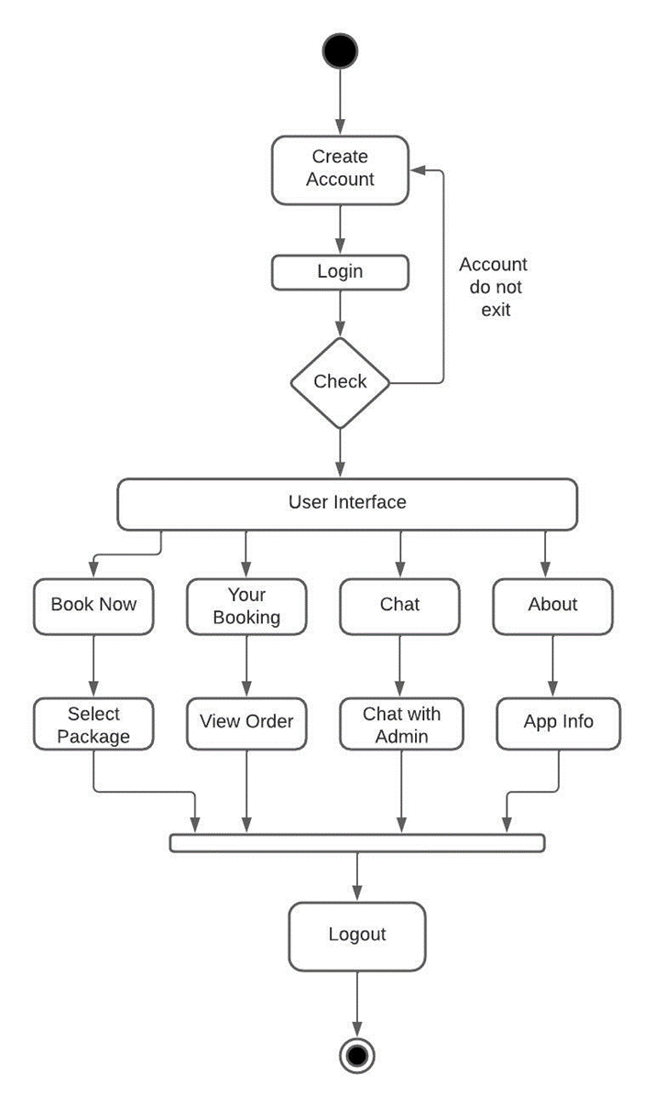

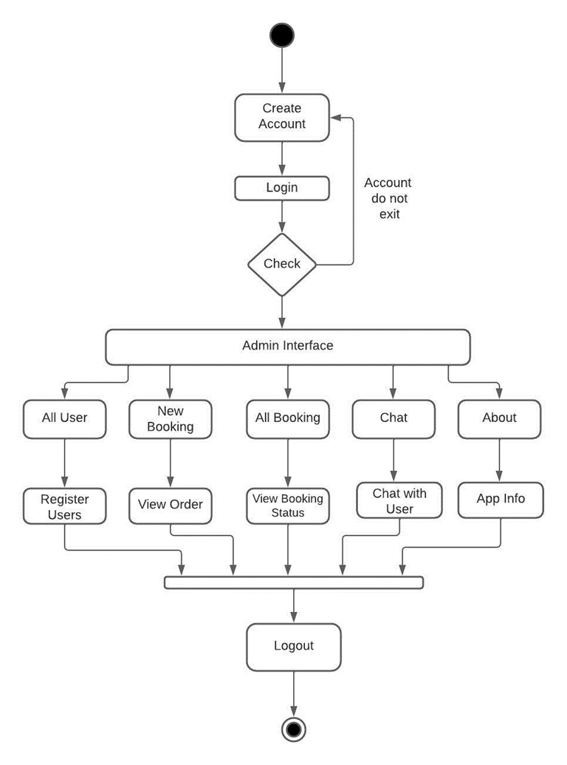

Activity diagram of washly is another important behavioral diagram in UML diagram to describe dynamic aspects of the system. This activity diagram is essentially an advanced Activity diagram of washly is another important behavioral diagram in UML diagram to describe dynamic aspects of the system. This activity diagram is essentially an advanced version of flowchart that models the flow from one activity to another activity. Activity diagrams are similar to flowcharts because they show the flow between the actions in an activity; however, in activity diagrams, an activity edge is a directed connection between two activity nodes. When a specific action in an activity is complete, the activity edge continues the flow to the next action in the sequence. However, the diagrams are a useful and effective modeling tool that can be used throughout the system development process. They help to visualize the functionality of the system at different levels of detail, and aid communication between admin and clients.

Figure 6

Package Diagram of Washly

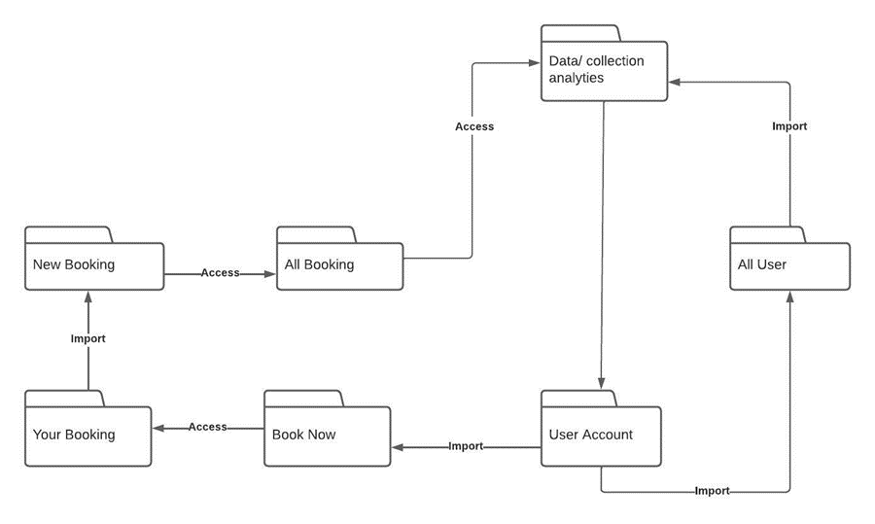A package diagram is used to arrange the components of a system, so packages can be used for large systems that contain diagrams and documents. The idea is to create a systematic representation of a set of instructions or procedures. The package diagram shows the interdependencies of the package and the process for each package. This diagram represents a package diagram with six different packages, representing the complex subsystem used to meet the requirements. One package depends on another if changes in the other could possibly force changes in the first.

The physical design is a graphical representation of a system showing the system’s internal and external entities, and the flows of data into and out of these entities. An internal entity is an entity (person, place, or thing) within the system that transforms data. Internal entities include, for example, accounting clerks (persons), departments (places), and computers (things). Whereas an external entity is an entity (person, place, or thing) outside the system that transforms data. Actually, the physical design relates to the actual input and output processes of the system. This Is laid down in terms of how data is given as an input into a system, how it is authenticated, how it is processed, and how it is displayed as output. Put another way, the physical portion of systems design can generally be broken down into three sub-tasks: 1. User Interface Design 2. Data Design 3. Process Design User Interface Design is concerned with how users add information to the system and with how the system presents information back to them. Data Design is concerned with how the data is represented and stored within the system.

The logical design of a system pertains to an abstract representation of the data flows, inputs, and outputs of the system. This is often conducted via modeling, using an over-abstract (and sometimes graphical) model of the actual system. Logical design is a graphical representation of a system showing the system's processes and the flows of data into and out of the processes. We use logical design to document information systems because we can represent the logical nature of a system-what tasks the system is doing, without having to specify how, where or by whom the tasks are accomplished.

Figure 7

Application Topology Mapping

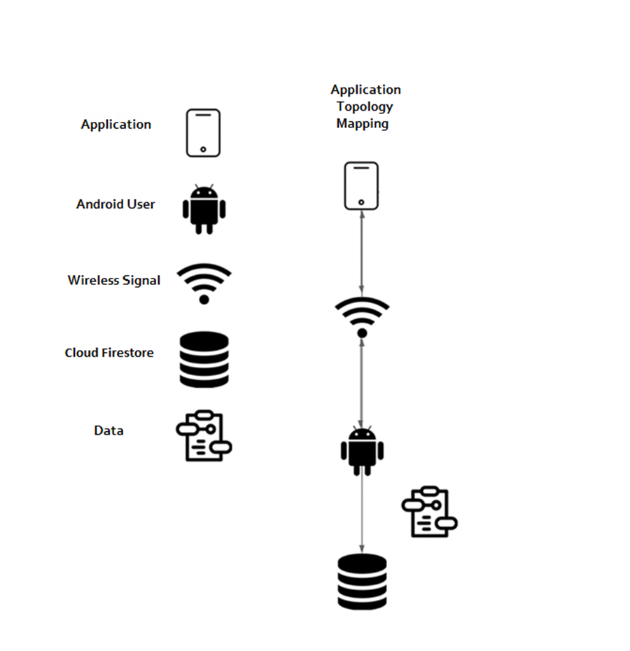

Application Topology Mapping. Is a subset of network topology, how different nodes in a network are connected to each other and how they communicate is determined by the network’s topology. Application topology mapping is designed to map or diagram the layout of the applications, and how they are currently performing in terms of efficiency and availability. Many application topology mapping software tools also combine sophisticated network mapping to provide real-time views and performance monitoring of all network devices, services, applications, and connections.

Figure 8

Deployment Diagram of Washly

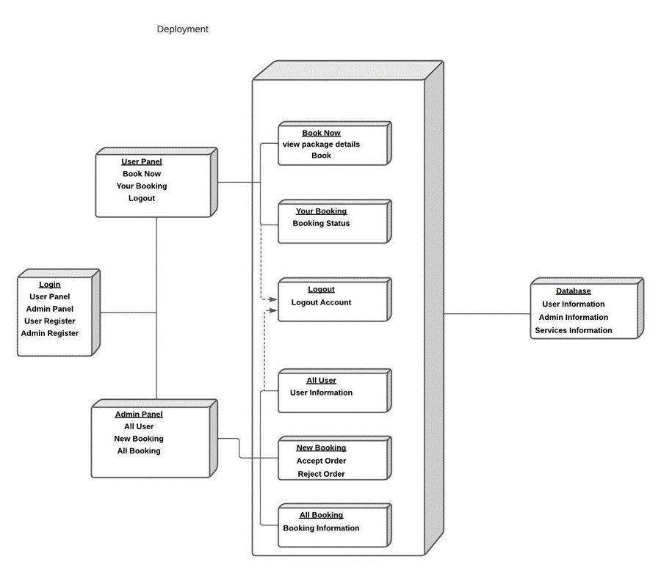

Deployment diagrams are typically used to visualize the physical hardware and software of a system which shows the execution architecture of a system including nodes such as hardware or software execution environments, and the middleware connecting them. They are often used to model the static deployment view of a system.

**Features of Washly**

This section discusses the features and functions that were implemented in the system for the users.

Figure 9 & 10

User Login and Registration

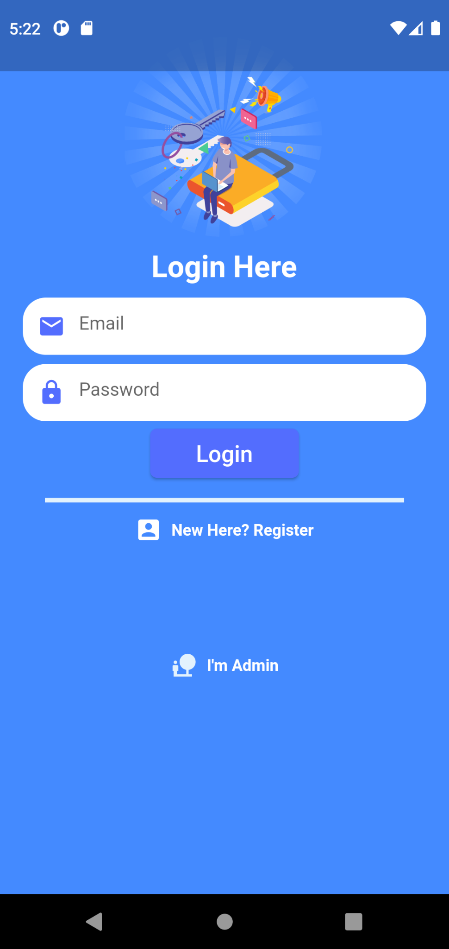

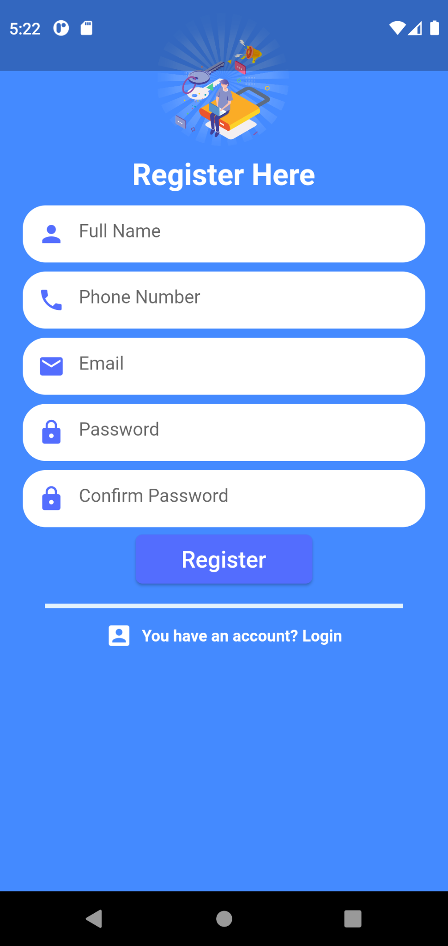

Figure 11

Opening Screen



It shows the opening page of the application, where it shows the logo of the application. The researchers designed a simple logo to attract our users.

Figure 12

Home Page

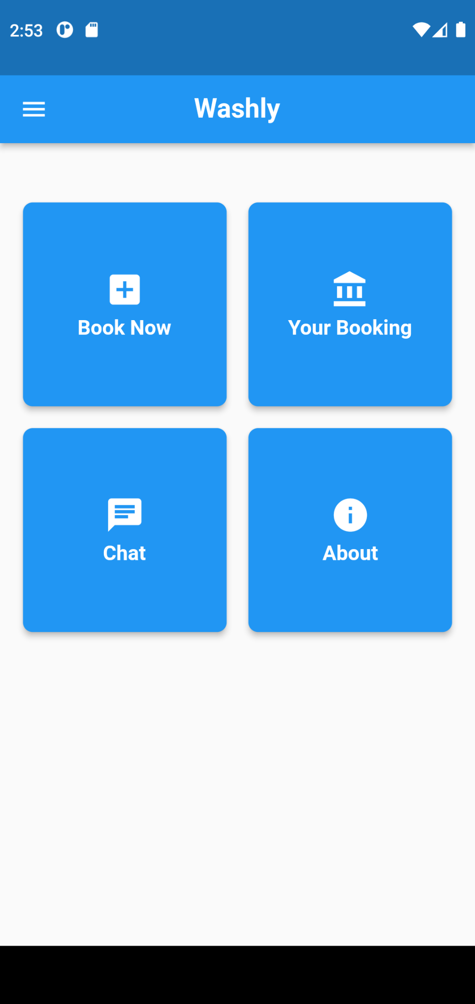

This shows the Home page. Where it is the primary page for the user to access through the different features.

Figure 13-18

Book Now page

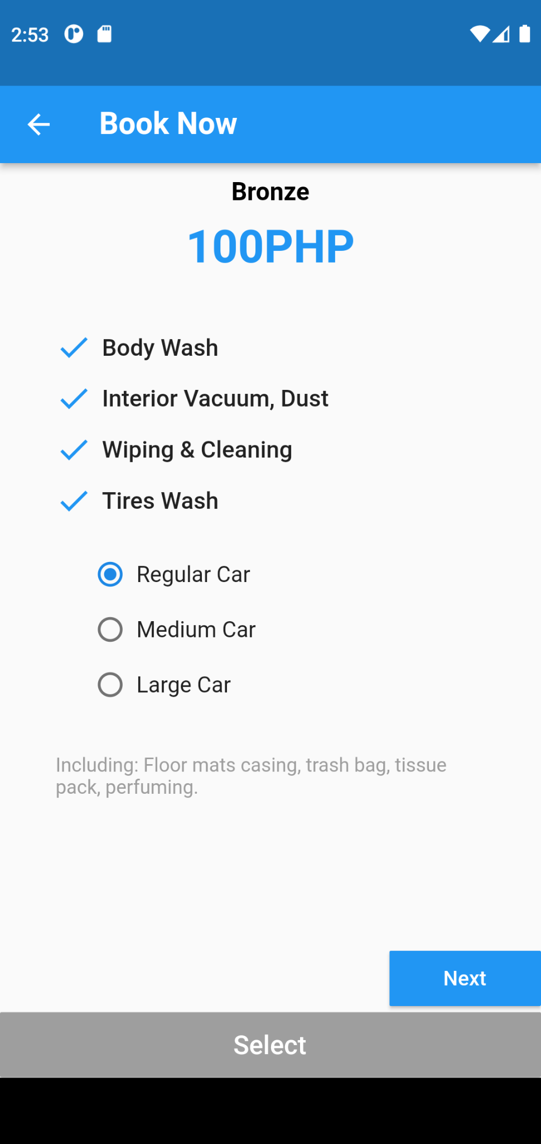

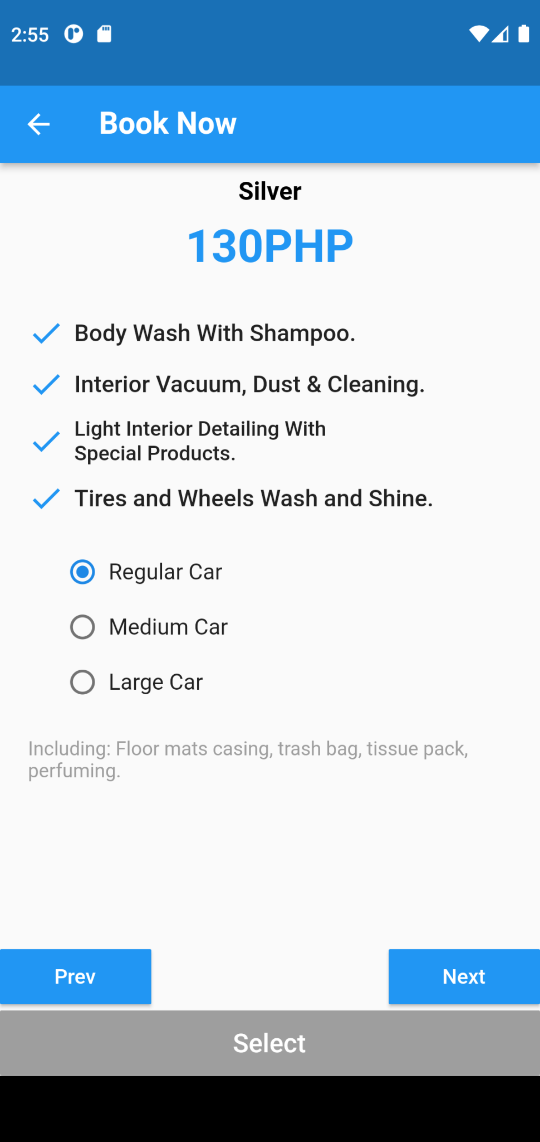

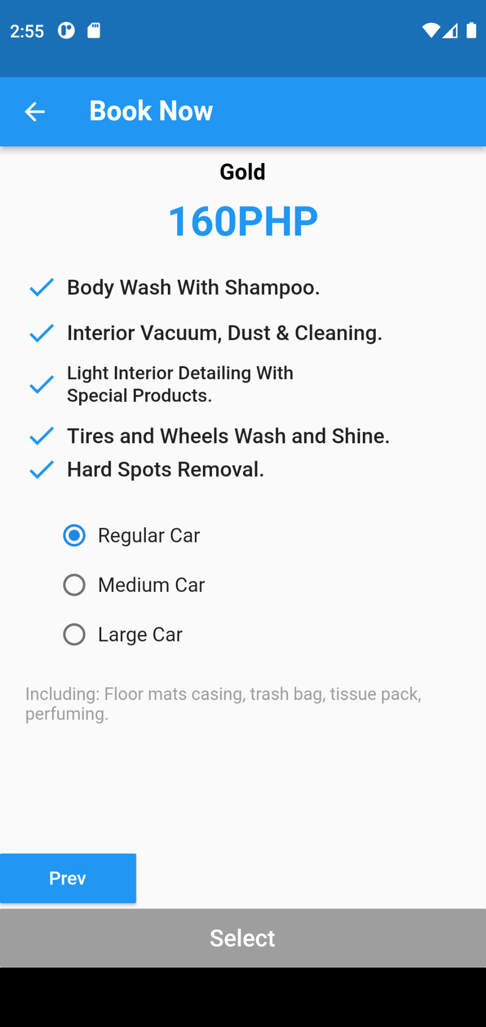

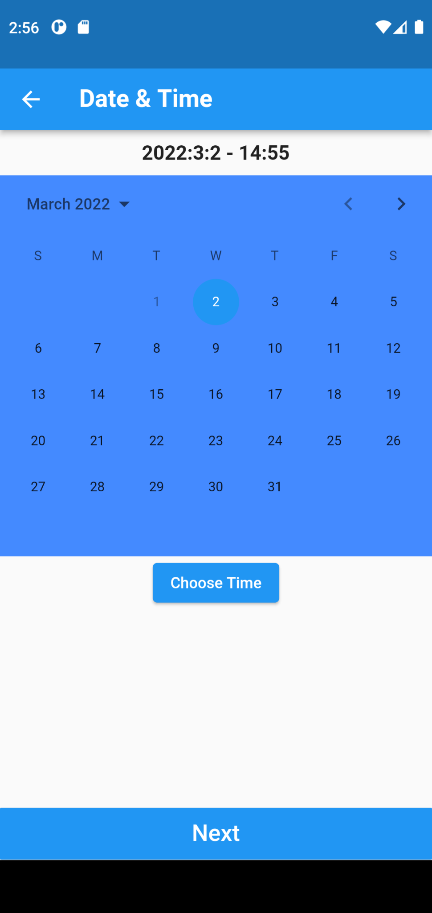

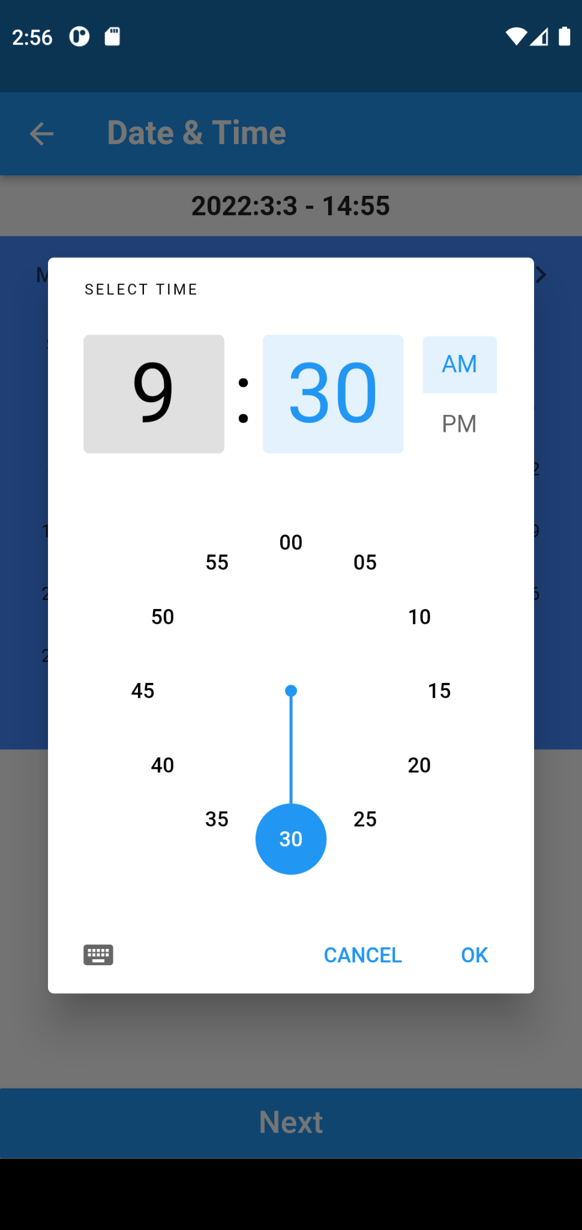

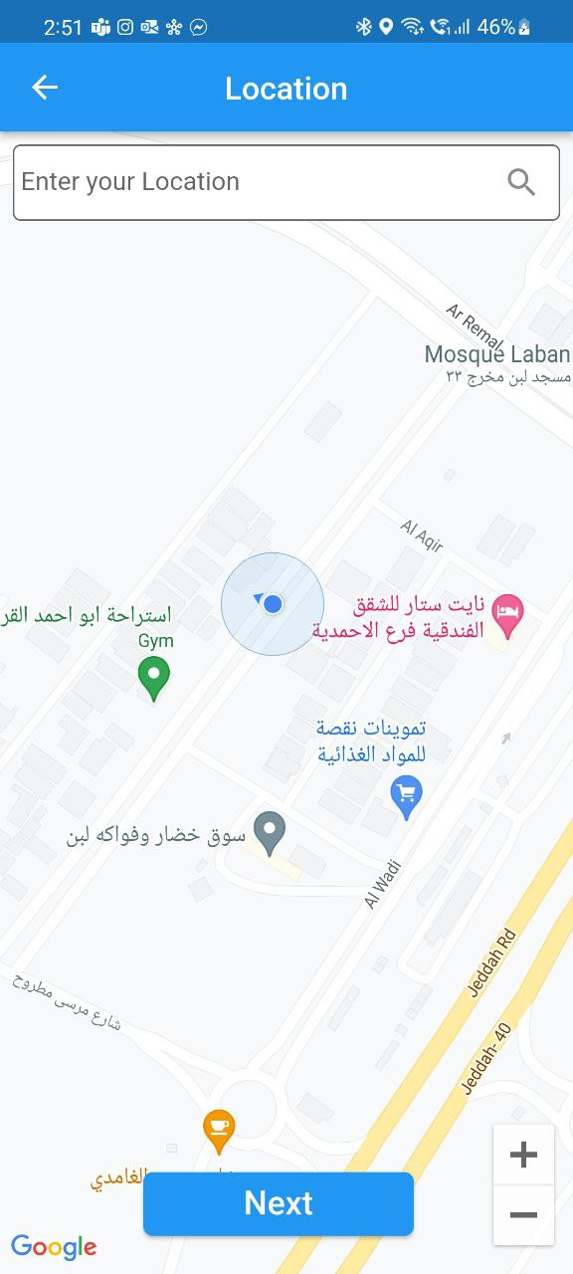

The pictures shows the packages and services available in each package with different car sizes, and after choosing the package. The date and time page comes for you to choose the date and time then the final step is to choose your location.

Figure 19

Your Booking Page

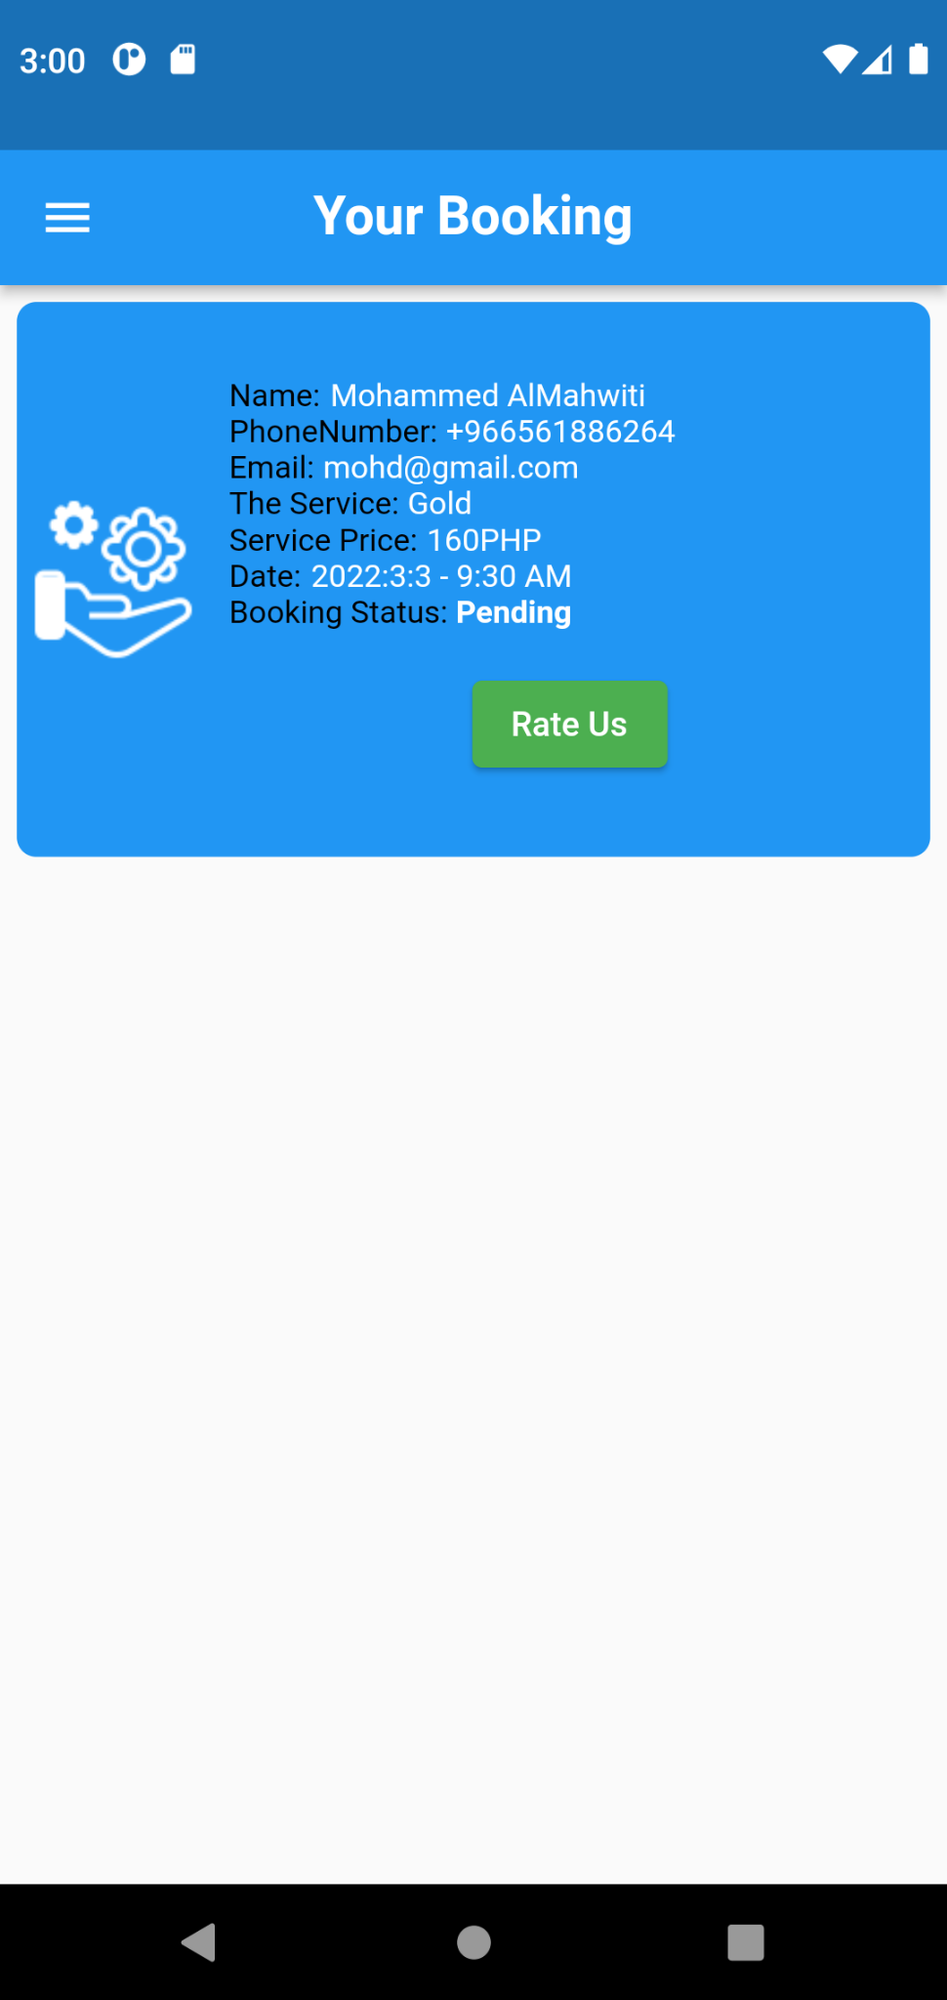

This feature shows the user information and booking status that the user had made.

Figure 20

User ChatBox

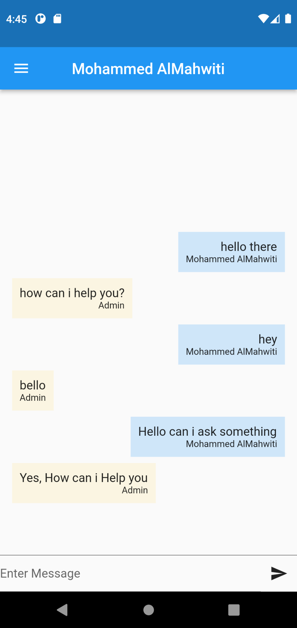

This feature allows the user to chat with the admin or the service provider.

Figure 21

Admin Home Page

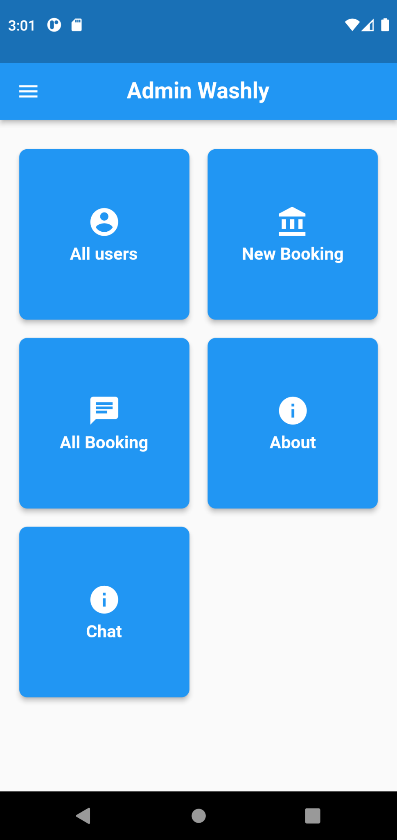

This shows the Admin Home page. where it is the primary page for the admin to access through the different features.

Figure 22

All users page

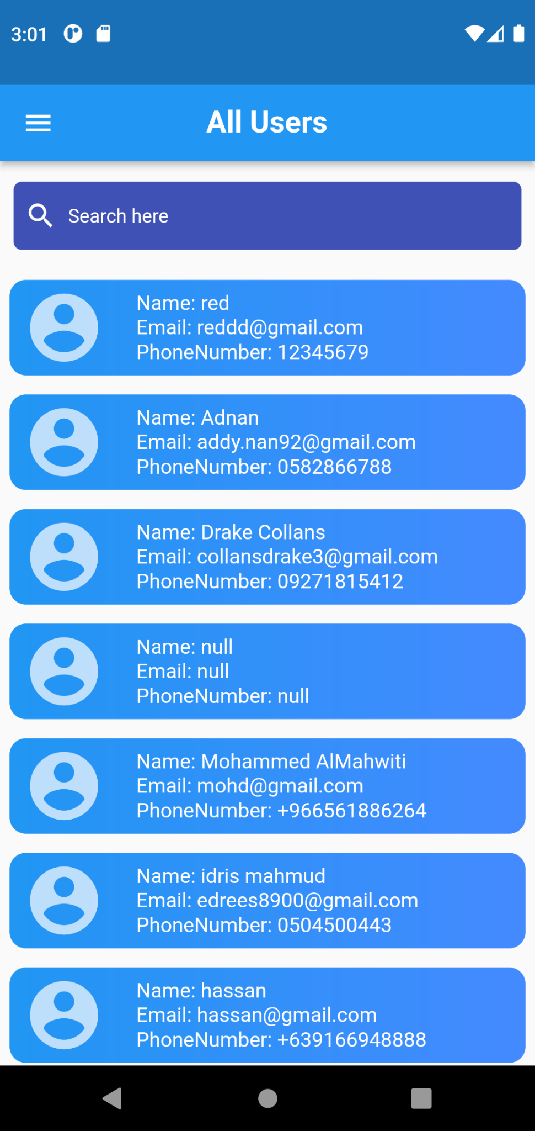

This feature shows the admin all the users that are registered or have an account in the application.

Figure 23

New Booking page

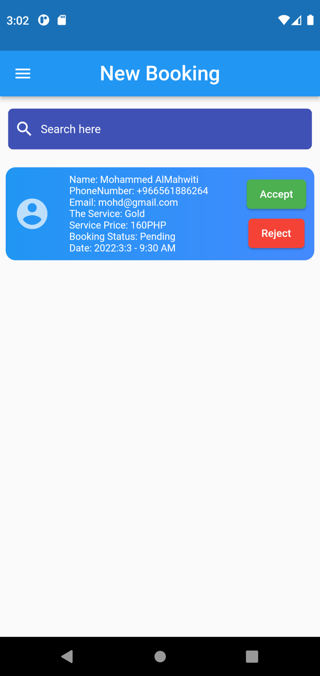

This feature shows the admin the new bookings that were made by the users for the admin to accept or reject.

Figure 24

All Booking page

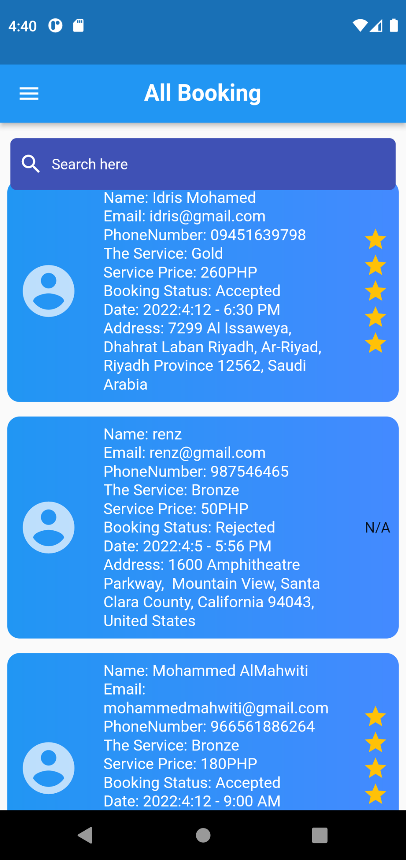

This feature shows the admin all the bookings that were made by the users and rates that were given by the user.

Figure 25

Admin Chat

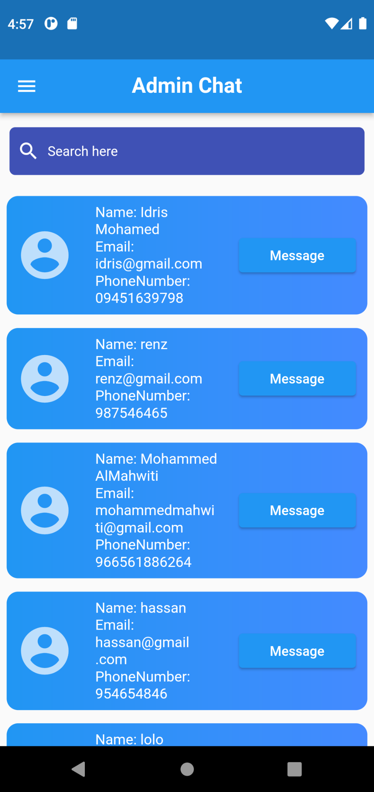

This feature allows the admin to chat with the users that booked a service.

**Measure of Usability**

This section discusses the measure of usability and how it would affect the proposed system. The researchers distributed survey questionnaires. The researchers conducted a survey to measure the user usability of the proposed system, with different answers from 100 people that have used car washes in the Philippines.

The respondents have used the system, 100 people answered 10 corresponding questions and rated it from level 1 to 5, based on their level of agreement. Level 1 of agreement means students have “strongly disagreed” into the corresponding questions given or totally disagreed, level 3 is a neutral level and level 5 means the students have “strongly agreed” or they totally agree on the corresponding SUS questionnaire given by the researchers.

The researchers have used all 100 of the answers from the data that the respondents have observed relating to the study. The researcher used the SUS questionnaire which was developed by John Brooke at Digital Equipment Corporation in the UK in 1996, SUS stands for System Usability Scale.

Slovin’s formula is used to calculate the sample size (n) given the population size (N) and a margin error (e). It’s a random sampling technique formula to estimate sampling size.

It is computed as n=N/(1+Ne^2).

Where:

n as the number of sample(s)

N as the total population

e as the Margin of Error(as a decimal)

The researchers specifically targeted people who have used car washes in the Philippines, wherein the users got an opportunity to test the system that shall give them car washing services. The respondents of the questionnaire tested and evaluated the system using the SUS questionnaire tool.

The SUS questionnaire has 10 items with one of the five

responses that range from strongly disagree to strongly agree.

The respondents gave various suggestions to the system

wherein there were mostly positive, and negative suggestions

which the researcher took note of towards the development of the system.

To compute the calculated scores, for odd numbers

(1,3,5,7,9) the user response is subtracted by 1, and second, for even numbers (2,4,6,8,10) the user response is subtracted from 5. All of the converted scores are added up and multiplied by 2.5. This converts the range 0 to 100 instead of 0 to 40.

SUS Average Score

∑SUS Scores / No. of Respondents = SUS Average Score

The formula above is to get the average score of the system. The researchers needed to calculate the average score using the formula given above. The researchers got the average score of 69, the system rate of calculated score is letter B which is good as shown below. It means the usability of the system is suited to the needs of the target users.

General Guideline of SUS Score

| SUS | SCORE | GRADE ADJECTIVE SCORE |
| --- | --- | --- |
| >80.3 | A | EXCELLENT |
| 68-80.3 | B | GOOD |
| 68 | C | OK |
| 51-68 | D | POOR |
| <51 | F | AWFUL |

Figure shows how the percentile ranks associate with SUS scores and letter grades.

This process is similar to “grading on a curve” based on the distribution of all scores. The overall mean result for the 100 respondents is 69.08. Based on the previous data, the project is acceptable and has a grade scale of B and a percentile rank of 69%. According to the result, it is therefore good.

Figure

Percentile Rank

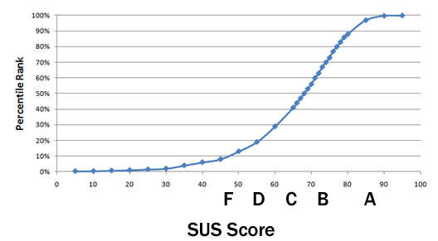

**Chapter 4**

**CONCLUSIONS AND RECOMMENDATIONS**

This chapter covers the summary and conclusions derived throughout the entire research, specifically from Chapter 3 which was the findings of the project. This also includes recommendations to future and current researchers and developers similar to that of this research.

**Conclusions**

In view of the objectives and findings of the study, below are the research’s conclusions.

1. Functionality and Content of the application Washly using the information requirements such as the Email of user, name, number, android, internal storage, internet access, target SDK version, cloud database, google map, Target SDK version API, Admin ID and Location of the user Information.

2. The Architectural Frameworks are represented through following diagrams; Use case Diagram, Activities Diagram, Package diagram and the Sequence Diagram is the logical design while the Deployment diagram show the physical design and Application Topology Mapping. Application topology mapping is designed to map or diagram the layout of the applications, and how they are currently performing in terms of efficiency and availability. Deployment diagrams show the configuration of runtime processing elements and the software components, processes, and objects that execute on them.

3. The main features of the proposed system are book now , view your bookings and chat features for the user and for the admin it includes view all users, view new booking, show all booking and chat features.​

4. Based on the result of the System Usability Scale, the researchers have received a score of 69**%** and according to the chart; this means that the proposed system has perceived acceptability of acceptable, a score letter of B on the measure of usability of the proposed system.

**Recommendations**

The following are the recommendations that could help to enhance the proposed system:

1. For future researchers to explore other software platforms that will fit the features of the system;

2. The researchers recommend future developers add a feature that lets users suggest locations to the admin;

3. For future researchers to develop a more improved

system that is more efficient and easier to navigate even by the age group not used to online platforms;

4. The researchers recommend future developers add an auto generated Chat from the admin feature wherein the app;

**REFERENCES**

Aatmaj, Janardanan (2018). Android Application for Car Wash Services, Retrieved from https://ieeexplore.ieee.org/abstract/document/8529025

Abagale, F. K., Sarpong (2013). Removal of Important Parameter from Car Wash Wastewater, Retrieved from https://doi.org/10.4028/www.scientific.net/AMM.773-774.1153

Alex Draghicescu (2018). Is it pointless to wash a car if it is going to rain the same day, Retrieved from https://www.quora.com/Is-it-pointless-to-wash-a-car-if-it-is-going-to-rain-the-same-day

Angel Ricardo (2021). How to Open a Car Wash Business, Retrieved from https://www.wikihow.com/Open-a-Car-Wash-Business

Anthony Analetto (2017). You’re always busy after bad weather, Retrieved from https://www.sonnysdirect.com/10_mistakes_people_make_when_starting_a_car_wash

Auto Bright (2015). The Benefits Of Car Washes, Retrieved from https://www.autobrightcarcare.com/the-benefits-of-car-washes/

Baguio.gov (2020). About Baguio City, Retrieved from https://www.baguio.gov.ph/about-baguio-city

Baguio.gov (2020). Implementation of car wash measure, Retrieved from https://www.baguio.gov.ph/content/city-needs-improve-coverage-implementation-car-wash-measure

Baguio.gov (2020). Climate in Baguio, Retrieved from https://www.baguio.gov.ph/about-baguio-city

chuntong chung (2014). How to Start a Car Wash Business, Retrieved from https://www.carmudi.com.ph/journal/start-car-wash-business/

CINDY (2019). Advantages of Using a Car Wash, Retrieved from http://advantagecollisioncenter.com/advantages-and-disadvantages-of-using-a-car-wash/

Coleman Kaufman, Sara Wilson (2021). Portable Car Wash, Retrieved from https://openscholarship.wustl.edu/jme410/39/https://openscholarship.wustl.edu/jme410/39/

Cote's Auto Body (2018). Important Reasons You Should Wash Your Car Regularly, Retrieved from https://cotesautobody.com/5-important-reasons-wash-car-regularly/

Cote's Auto Body (2018). Avoiding Damage, Retrieved from https://cotesautobody.com/5-important-reasons-wash-car-regularly/

Dan, Sweeney (2020). How Often Should You Wash Your Car?, Retrieved from https://www.torquedetail.com/blogs/car-detailing/how-often-should-you-wash-your-car

Detail Xperts (2019). Mobile Car Wash, Retrieved from https://www.detailxperts.net/northlosangeles/blog/mobile-car-wash-5-advantages-of-using-this-type-of-service/

Detail Xperts (2019). friendly option, Retrieved from https://www.detailxperts.net/northlosangeles/blog/mobile-car-wash-5-advantages-of-using-this-type-of-service/

Ellie, McCardwell (2020). What is Car Detailing, Retrieved from https://www.mobiletechrx.com/resources/how-to-start-a-car-detailing-business/

Elsevier B.V. (2007). Carwash water reclamation in Kuwait, Retrieved from https://www.sciencedirect.com/science/article/abs/pii/S0011916406013956

fieldd (2020). Mobile Car Wash Business Plan, Retrieved from https://fieldd.co/how-to-start-a-mobile-car-wash-business/

Flagstop Car Wash (2020). Protect your investment, Retrieved from https://flagstopcarwash.com/five-unexpected-benefits-of-regular-car-washing

getspiffy (2014). Mobile Car Care at Home, Retrieved from https://www.getspiffy.com/at-home

Giti, Kashi (2021). Carwash wastewater treatment using the chemical processes, Retrieved from https://doi.org/10.2166/wst.2021.206

Harakh, Dustin (2018). Dream Klean Car Wash business plan, Retrieved from http://scholarworks.csustan.edu/handle/011235813/1365

Hesen LiEmail, authorZixian Zheng (2019). Innovative Design of Self-service Car Wash Service System, Retrieved from https://link.springer.com/chapter/10.1007/978-3-030-25128-4_25

In-N-Out-Car-Wash (2017). Keep it Fresh**,** Retrieved from https://inoutcarwash.com/benefits-of-a-regular-car-wash/

jhulianna, bautista (2018). Baguio City, Retrieved from https://batangas6.home.blog/

Josh, Wilkins (2020). Washing After Rain, Retrieved from https://everydayshowcar.com/wash-car-rain/

Khatabook (2018). Making a car wash business plan, Retrieved from https://khatabook.com/blog/how-to-start-car-wash-and-bike-wash-business-in-india/

Kit, Jenkin (2021). How Much Car Wash Owners Make, Retrieved from https://www.eposnow.com/ca/resources/how-much-do-car-wash-owners-make/

Leonilda Mamoto (2020). Why does my car get dirty when it rains, Retrieved from https://findanyanswer.com/why-does-my-car-get-dirty-when-it-rains

Linnaeus ECO-TECH (2012). Biological Treatment of Car Wash Waste Waters, Retrieved from https://open.lnu.se/index.php/eco-tech/article/view/494

Liza, Agoot (2021). Smart City Command Center to improve services in Baguio, Retrieved from https://www.pna.gov.ph/articles/1153128

Michael Kormos Daily Sun (2021). Car wash owner adjusts to thrive amid pandemic, Retrieved from https://www.corsicanadailysun.com/covid-19/car-wash-owner-adjusts-to-thrive-amid-pandemic/article_5e40d5e4-6270-11eb-ae09-97ea665bb877.html

*Mike Ales* (2020). Rain has too much of what your car doesn’t need, Retrieved from https://www.columbiatireauto.com/Blog/ID/314/Why-Rain-Is-Not-a-Substitute-for-Washing-Your-Car

Novus (2020). How To: Keeping Your Car Clean and Hygienic During COVID-19, Retrieved from https://novusautoglass.com.au/newsrooms/how-to-keeping-your-car-clean-and-hygienic-during-covid-19/

nuwash (2019). Meet your personal car washing service, Retrieved from https://nuwashcarwash.com

Philippines.Travel(2018). Welcome To Baguio city, Retrieved from https://philippines.travel/destinations/baguio-city

Research and Markets (2020). Car Washing Services Amid COVID-19, Retrieved from https://www.prnewswire.com/news-releases/car-washing-services-amid-covid-19---companies-have-responded-to-covid-19-hygiene-concerns-with-new-cleaning-solutions-301063700.html

Rich DiPaoloon (2020). The effect of the pandemic on carwashing, Retrieved from https://www.carwash.com/effect-pandemic-carwashing/

Shari Prymak (2021). COVID-19 Guide to Cleaning Your Car During a Global Pandemic, Retrieved from https://www.carhelpcanada.com/covid-19-guide-to-cleaning-your-car-during-a-global-pandemic/

Supersonic Car Wash (2020). COVID-19 Update: Changes in Car Wash Operations, Retrieved from https://supersonic1.com/march-16-2020-covid-19-update-changes-in-car-wash-operations/

The business plan (2016). What do customers want in a car wash, Retrieved from https://www.thebusinessplanshop.com/en/blog/market-research-car-wash

The business plan (2016). Conducting market research to open a car wash, Retrieved from https://www.thebusinessplanshop.com/en/blog/how-to-open-a-car-wash

THE DIRT BUSTER (1993). Car Wash, Retrieved from https://www.referenceforbusiness.com/business-plans/Business-Plans-Volume-01/Car-Wash.html

Tommy Car Wash Systems (2015), Research Car Washes, Retrieved from https://blog.tommycarwash.com/10-steps-for-starting-a-car-wash-from-the-ground-up

Tommy Terrific's Car Wash (2020), What is the best strategy in an automatic car wash, Retrieved from https://www.tommyterrificscarwash.com/press/dallas-is-it-safe-to-take-the-car-to-a-car-wash-in-the-middle-of-the-pandemic

Todd Davy (2020), The Complete Guide to Running a Thriving Car Wash in a Pandemic, Retrieved from https://drb.com/resources/learning_library/running_car_wash_during_coronavirus

TopFranchiseTEAM (2021), The Best 5 Car Wash Franchises in The Philippines in 2021, Retrieved from https://topfranchise.com/articles/the-best-5-car-wash-franchises-in-the-philippines-in-2019/

TRUIC (2021), How To Start A Car Wash, Retrieved from https://howtostartanllc.com/business-ideas/car-wash

**APPENDICES**

**APPENDIX A**

**SUS QUESTIONNAIRE**

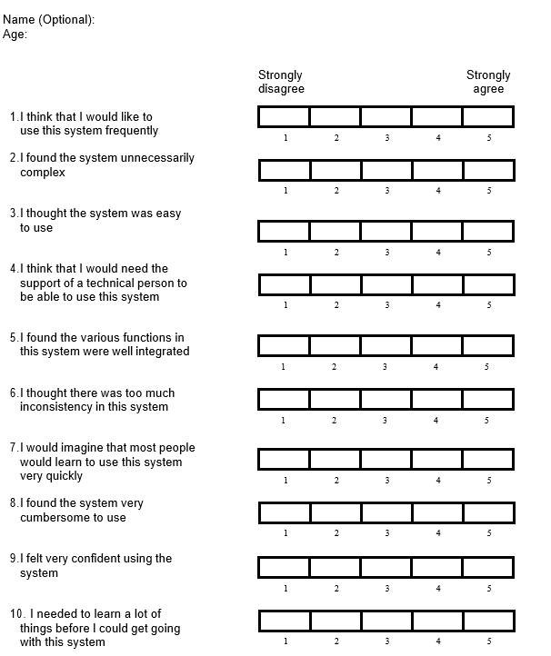

# **Appendix B**

# **SAMPLE RESULT OF TESTING**

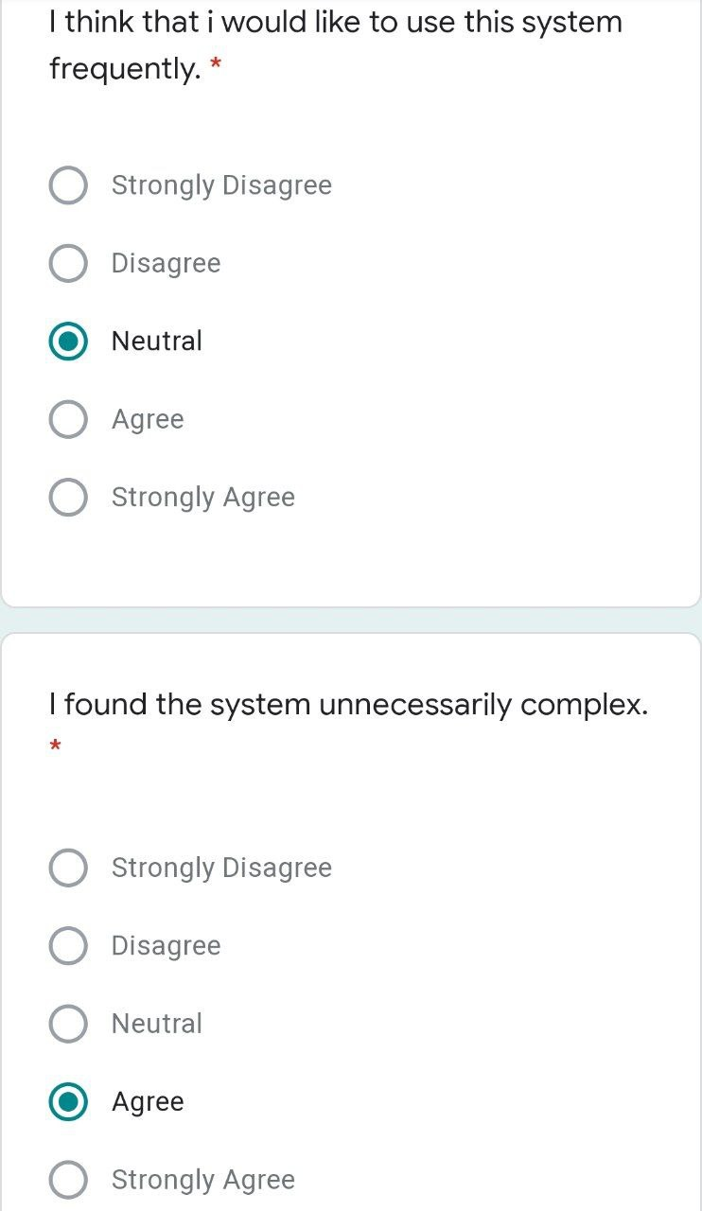

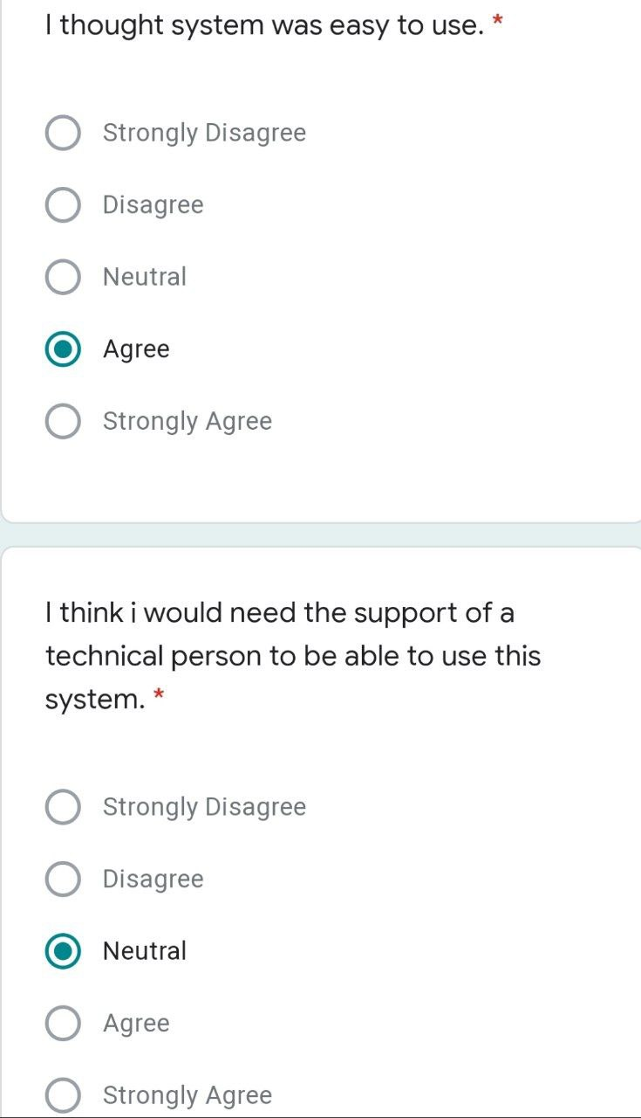

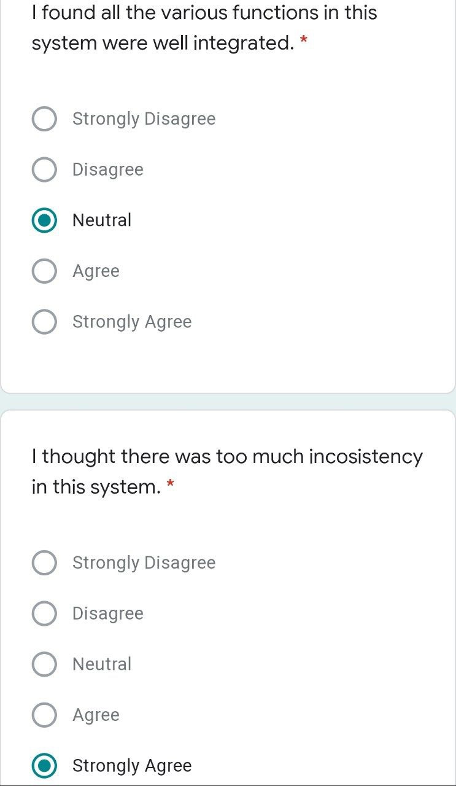

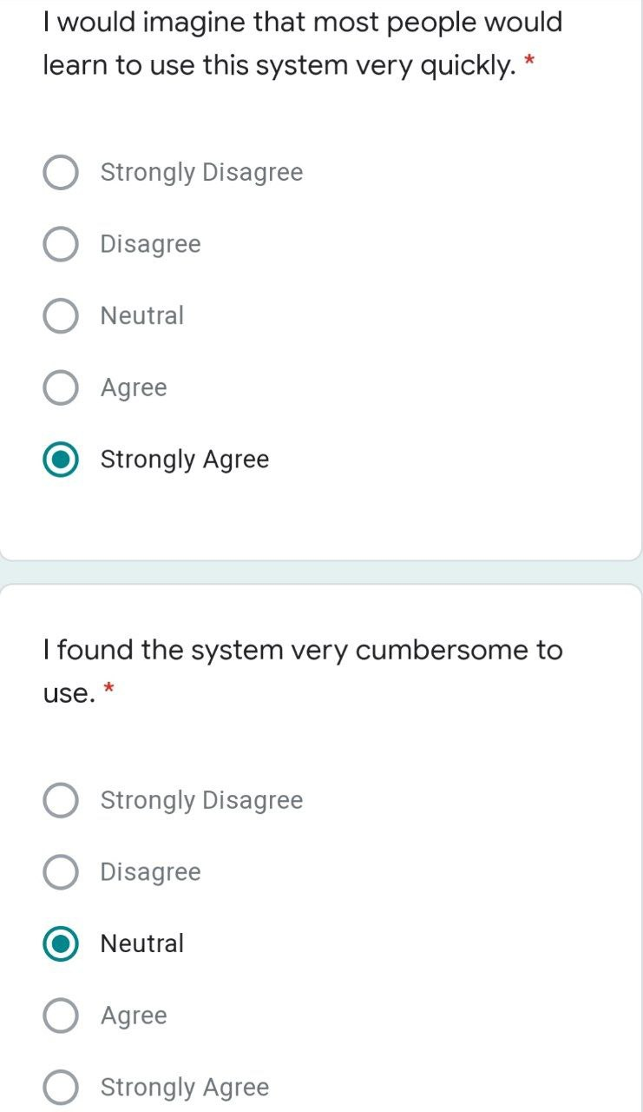

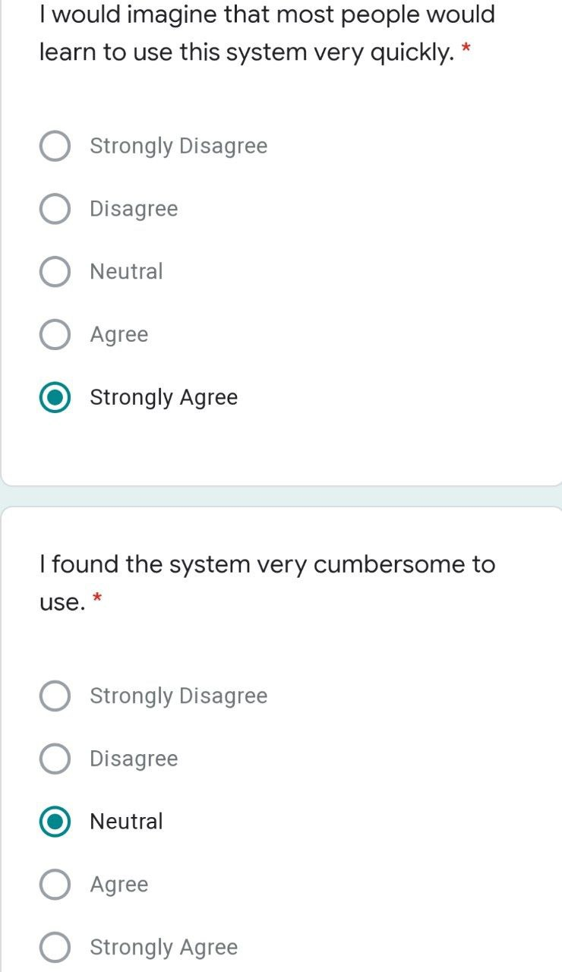

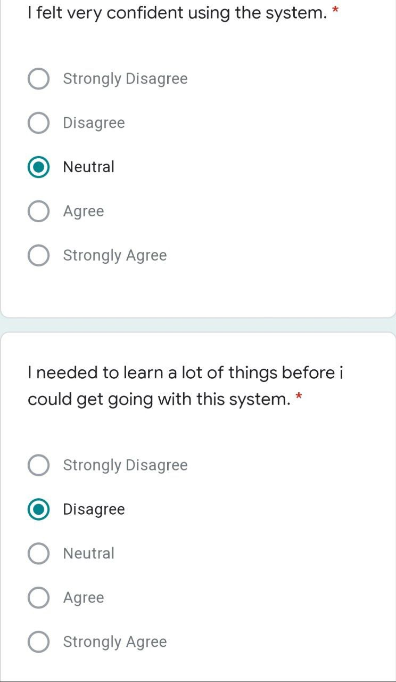

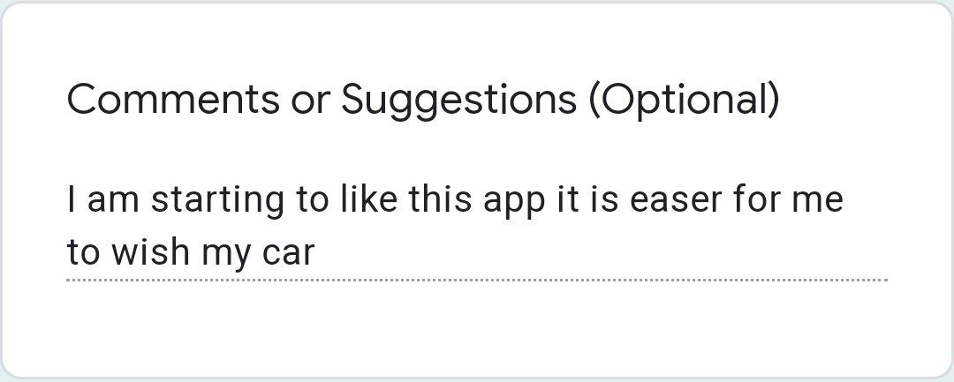

# **Appendix C**

# **IMPORTANT CODES**

Future <void> main() async {

WidgetsFlutterBinding.*ensureInitialized*();

sharedPreferences = await SharedPreferences.*getInstance*();

await Firebase.*initializeApp*();

runApp(const MyApp());

}

class MyApp extends StatelessWidget {

const MyApp({Key? key}) : super(key: key);

@override

Widget build(BuildContext context) {

return MaterialApp(

title: "Washly App",

debugShowCheckedModeBanner: false,

theme: ThemeData(

primaryColor: Colors.*blue*,

),

home: const MySplashScreen(),

);

}

}

name: wishy

description: wishy is an application to book washing services online

*# The following line prevents the package from being accidentally published to*

*# pub.dev using `flutter pub publish`. This is preferred for private packages.*

publish_to: 'none' *# Remove this line if you wish to publish to pub.dev*

*# The following defines the version and build number for your application.*

*# A version number is three numbers separated by dots, like 1.2.43*

*# followed by an optional build number separated by a +.*

*# Both the version and the builder number may be overridden in flutter*

*# build by specifying --build-name and --build-number, respectively.*

*# In Android, build-name is used as versionName while build-number used as versionCode.*

*# Read more about Android versioning at https://developer.android.com/studio/publish/versioning*

*# In iOS, build-name is used as CFBundleShortVersionString while build-number used as CFBundleVersion.*

*# Read more about iOS versioning at*

*# https://developer.apple.com/library/archive/documentation/General/Reference/InfoPlistKeyReference/Articles/CoreFoundationKeys.html*

version: 1.0.0+1

environment:

sdk: ">=2.12.0 <3.0.0"

*# Dependencies specify other packages that your package needs in order to work.*

*# To automatically upgrade your package dependencies to the latest versions*

*# consider running `flutter pub upgrade --major-versions`. Alternatively,*

*# dependencies can be manually updated by changing the version numbers below to*

*# the latest version available on pub.dev. To see which dependencies have newer*

*# versions available, run `flutter pub outdated`.*

dependencies:

flutter:

sdk: flutter

firebase_core: ^1.4.0

cloud_firestore: ^3.1.6

firebase_auth: ^3.0.1

shared_preferences: ^2.0.6

fluttertoast: ^8.0.8

flutter_svg: ^1.0.3

image_picker: ^0.8.3+2

firebase_storage: ^10.0.1

provider: ^6.0.2

path_provider: ^2.0.1

flutter_easyloading: ^3.0.0

image: ^3.0.2

geocoding: ^2.0.2

geolocator: ^8.1.1

cupertino_icons: 1.0.0

google_maps_flutter: ^2.0.1

flutter_bloc: ^8.0.1

flutter_rating_bar: ^4.0.0

rflutter_alert: ^1.0.3

flutter_chat_ui: ^1.5.5

flutter_staggered_grid_view: ^0.4.1

dev_dependencies:

flutter_test:

sdk: flutter

*# The "flutter_lints" package below contains a set of recommended lints to*

*# encourage good coding practices. The lint set provided by the package is*

*# activated in the `analysis_options.yaml` file located at the root of your*

*# package. See that file for information about deactivating specific lint*

*# rules and activating additional ones.*

flutter_lints: ^1.0.0

*# For information on the generic Dart part of this file, see the*

*# following page: https://dart.dev/tools/pub/pubspec*

*# The following section is specific to Flutter.*

flutter:

*# The following line ensures that the Material Icons font is*

*# included with your application, so that you can use the icons in*

*# the material Icons class.*

uses-material-design: true

*# To add assets to your application, add an assets section, like this:*

assets:

- assets/img/car-wash.jpg

- assets/img/login.png

- assets/img/admin.png

- assets/img/logo.png

- maintenance4+.png

*# - images/a_dot_ham.jpeg*

*# An image asset can refer to one or more resolution-specific "variants", see*

*# https://flutter.dev/assets-and-images/#resolution-aware.*

*# For details regarding adding assets from package dependencies, see*

*# https://flutter.dev/assets-and-images/#from-packages*

*# To add custom fonts to your application, add a fonts section here,*

*# in this "flutter" section. Each entry in this list should have a*

*# "family" key with the font family name, and a "fonts" key with a*

*# list giving the asset and other descriptors for the font. For*

*# example:*

*# fonts:*

*# - family: Schyler*

*# fonts:*

*# - asset: fonts/Schyler-Regular.ttf*

*# - asset: fonts/Schyler-Italic.ttf*

*# style: italic*

*# - family: Trajan Pro*

*# fonts:*

*# - asset: fonts/TrajanPro.ttf*

*# - asset: fonts/TrajanPro_Bold.ttf*

*# weight: 700*

*#*

*# For details regarding fonts from package dependencies,*

*# see https://flutter.dev/custom-fonts/#from-packages*

**CURRICULUM VITAE**

| **MOHAMMED F. AL-MAHWITI**  📫 #Aurora Hill, Baguio City  🕿 +966561886264  🖳 mohammedmahwiti@gmail.com | | |  |
| --- | --- | --- | --- |
|  | | | |
| **WORK EXPERIENCE** | | | |
| **Customer Service &**  **Supervisor For IELTS test** | : British Council  : Al Fazary Square, C14 office 1st floor، Riyadh  : May 2017 – Present | | |
| **EDUCATIONAL ATTAINMENT** | | | |
| **Tertiary** | **: Bachelor of Science in Information Technology**  **: Network & Security Track**  **:** University of the Cordilleras  : Gov. Pack Rd., Baguio City  **:** Expected Date of Graduation: August 2022 | | |
| **Secondary** | **:** Al-Noor International School  **:** 4312 Al Hasi, Al Wisham, Riyadh 12741  : May 2017 | | |
| **Primary** | : Al-Noor International School  : 4312 Al Hasi, Al Wisham, Riyadh 12741  : Mary 2011 | | |
| **SKILLS AND QUALIFICATIONS** | | | |
| * Knowledgeable in CISCO LAN Switches and routers, installation and configuration (CCNA1 to CCNA 4) * Knowledgeable in programming languages * Strong verbal and personal communication skills | | | |
| **SEMINARS and TRAININGS ATTENDED** | | | |
| * Child Protection   22nd October, 2017  British Council | | | |
| **PERSONAL INFORMATION** | | | |
| Date of Birth | | : February 9, 1998 | |
| Age | | : 24 years old | |
| Height | | : 178cm | |
| Weight | | : 93 kgs. | |
| **CHARACTER REFERENCES** | | | |
| Name | | Anna Rhodora M. Quitaleg | |
| Position | | Instructor, CITCS | |
| Company | | University of the Cordilleras | |
| Contact Number | | (074) 442-3316 local 214 | |
| Email Address | | oliangelanne@yahoo.com | |
|  | |  | |
| Name | | Khaled Idrees | |
| Position | | Customer Service Manager | |
| Company | | British Council | |
| Contact Number | | +966540739123 | |
| Email Address | | Khaled.Idrees@britishcouncil.org | |
|  | |  | |
|  | |  | |
|  | |  | |
|  | |  | |
|  | |  | |
|  | |  | |

| **IDRIS, MAHMUD IDRIS MOHAMED**  📫 #Campo Sioco, Baguio City  🕿 +966504500443  🖳 edrees8900@gmail.com | | |  |
| --- | --- | --- | --- |
|  | | | |
| **EDUCATIONAL ATTAINMENT** | | | |
| **Tertiary** | **: Bachelor of Science in Information Technology**  **: Network & Security Track**  **:** University of the Cordilleras  : Gov. Pack Rd., Baguio City  **:** Expected Date of Graduation: August 2022 | | |
| **Secondary** | **:** Eritrean International School  **:** Al-Mushrifah, Jeddah city  : April 2015 | | |
| **Primary** | : Al-Mawarid International school  : Al-Mushrifah, Jeddah city  : March 2004 | | |
| **SKILLS AND QUALIFICATIONS** | | | |
| * Knowledgeable in SAP ERP System Configuration * Knowledgeable in CISCO LAN Switches and routers, installation and configuration (CCNA1 to CCNA 4) * Strong verbal and personal communication skills * (include IT certifications if any, e.g. CISCO Certified Network Associate) | | | |
| **SEMINARS and TRAININGS ATTENDED** | | | |
| * Web application development (HTML, CSS) | | | |
| **PERSONAL INFORMATION** | | | |
| Date of Birth | | : October 07, 2000 | |
| Age | | : 21 years old | |
| Height | | : 6’2” | |
| Weight | | : 125 kgs. | |
| **CHARACTER REFERENCES** | | | |
| Name | | Anna Rhodora M. Quitaleg | |
| Position | | Instructor, CITCS | |
| Company | | University of the Cordilleras | |
| Contact Number | | (074) 442-3316 local 214 | |
| Email Address | | oliangelanne@yahoo.com | |
|  | |  | |
| Name | |  | |
| Position | |  | |
| Company | |  | |
| Contact Number | |  | |
| Email Address | |  | |
|  | |  | |
| Name | |  | |
| Position | |  | |
| Company | |  | |
| Contact Number | |  | |
| Email Address | |  | |



| **EDMOND AUJAY TARYOUWAY**  📫 # Lexberville SUBD, Baguio City  🕿 +9564104919  🖳 taryouwaye@gmail.com | | |  |
| --- | --- | --- | --- |
|  | | | |
| **WORK EXPERIENCE** | | | |
| **Network Administrator**  **System Administrator** | : Techno I.T  : Monrovia City  : December 2018 – June 2019  : LA Technology Global  : Montserrado County  : May 2018 – October 2018 | | |
| **EDUCATIONAL ATTAINMENT** | | | |
| **Tertiary** | **: Bachelor of Science in Information Technology**  **: Network & Security Track**  **:** University of the Cordilleras  : Gov. Pack Rd., Baguio City  **:** Expected Date of Graduation: August 2022 | | |
| **Secondary** | **:** BlueCrest University College/ NIIT  **:** Monrovia City, Liberia  : August 2017 | | |
| **Primary** | : College Of West Africa  : Ahmnus Street, Monrovia, Liberia  : August 2016 | | |
| **SKILLS AND QUALIFICATIONS** | | | |
| * Knowledgeable in CISCO LAN Switches and routers, installation and configuration (CCNA1 to CCNA 4) * Knowledgeable in programming languages * Knowledgeable in SAP ERP System Configuration * Strong verbal and personal communication skills | | | |
| **SEMINARS and TRAININGS ATTENDED** | | | |
| * IT Assistant   2nd February 2018  National Bureau of Concessions | | | |
| **PERSONAL INFORMATION** | | | |
| Date of Birth | | : April 23, 1994 | |
| Age | | : 27 years old | |
| Height | | : 174cm | |
| Weight | | : 65 kgs. | |
| **CHARACTER REFERENCES** | | | |
| Name | | Anna Rhodora M. Quitaleg | |
| Position | | Instructor, CITCS | |
| Company | | University of the Cordilleras | |
| Contact Number | | (074) 442-3316 local 214 | |
| Email Address | | oliangelanne@yahoo.com | |
|  | |  | |  |
| Name | |  | |  |
| Position | |  | |  |
| Company | |  | |  |
| Contact Number | |  | |  |
| Email Address | |  | |  |
|  | |  | |  |
| Name | |  | |  |
| Position | |  | |  |
| Company | |  | |  |
| Contact Number | |  | |  |
| Email Address | |  | |  |